
Project Final Report
Zagraniczna praktyka podstawą profesjonalizmu i spolecznej integracji techników na europejskim rynku pracy
2017-1-PL01-KA102-036067

BETWEEN
The Sending Organization
Zespol Szkol Technicznych i Ogolnoksztalcacych w Skoczowie
AND
The Intermediary Organisation
Euromind Projects SL

Training Programme Dates
01-10-2018 - 26-10-2018

EUROMIND AS PROJECT PARTNER
1. Profile Description
euroMind is an international training consultancy and VET provider with headquarters in Seville and Úbeda in Andalusia (Spain).
euroMind as a training provider delivers vocational education trainings, general and job-related language courses, VET training-related workshops and study visits, workshops on culture, lifestyle and customs of EU countries as well as classes on skilful and effective job search in the EU.
It promotes and delivers trainings for teaching staff and secures work placements and exchange activities for VET students and graduates enabling at the same time young people and professionals to make the most out of opportunities of competencies & skills development offered by European educational programmes.
euroMind in partnership with Andalusian vocational colleges and companies delivers school based vocational trainings for students of different educational fields, such as: CNC, automation, electricity, renewable energy sources, plumbing, industrial and graphic design, 3D design, ICT, electronics, administration.
euroMind as a VET provider works in partnership with a wide array of private companies in almost all the sectors, such as tourism, business administration, medicine, fashion, hairdressing, health & beauty, physiotherapy, marketing, media, advertising, public relations, tourism, IT, social work, logistics, nursing, construction, geodesy, analytics etc.
2. euroMind experience and expertise
The euroMind possesses extensive experience and expertise in the field of European mobility projects preparation and management which allows it to assist Spanish vocational colleges and governmental institutions with the preparation of project applications, finding trustworthy and competent host partners in Europe for their project participants, teaching and HR staff.

Over last 3 year euroMind has participated as a receiving – host partner in over 60 mobility projects with the participation of a total of 1800 persons: students from technical and vocational schools, university students, graduates, unemployed and teaching and HR staff. These projects involved partners from Poland, Great Britain, Czech Republic, Slovakia, Germany, Portugal, Turkey, Croatia, Italy, Greece, Bulgaria, Lithuania, Latvia, etc. The full list of projects including numbers and titles is available on the euroMind website: www.euromind.es in the Gallery.

euroMind is also responsible for the participants’ linguistic, socio-cultural and practical preparation and also, if necessary, for the project administration and management issues.

euroMind has been participating as a sending and host organization in more than 100 projects including Leonardo Partnership, Erasmus Placement and Leonardo Mobility – PLM, VETpro and IVT and Erasmus + projects.

euroMind monitors that all the required documentation is prepared and submitted on time at every stage of the project lifecycle and makes sure that all the partners carry out their responsibilities.

euroMind participates in seminars organised by ECVET team regarding the use of system
of transfer of competences and skills in the vocational training. euroMind experts have
extensive knowledge in the field, hence they are able to train their partners on how to
make use of this system in their projects.

euroMind has an impressive network of partner companies from different economic sectors. More than 400 entities both private and public cooperate with euroMind in Ubeda, Seville and Cracow. This extensive activity is a perfect guarantee that all the students received by euroMind will be successfully placed.

PROJECT PARTICIPANTS’ LIST
Participants’ Name | Placement Sector
Maciej Byrtek | Car mechanic
Tomasz Cieślar | Electronic
Kacper Gabzdyl | Car mechanic
Dominik Kohut | Electronic
Kamil Król | Electronic
Szymon Madecki | Electronic
Michał Madzia | Car mechanic
Adam Malina | Car mechanic
Łukasz Martynek | Car mechanic
Marcel Nawrat | Electronic
Paweł Pałka | Car mechanic
Jakub Pietrasina | Electronic
Bartłomiej Sidzina | Car mechanic
Łukasz Sikora | Car mechanic
Damian Stebel | Car mechanic
Marcin Surmiak | Electronic
Krzysztof Szworc | Electronic
Michał Szyndler | Car mechanic

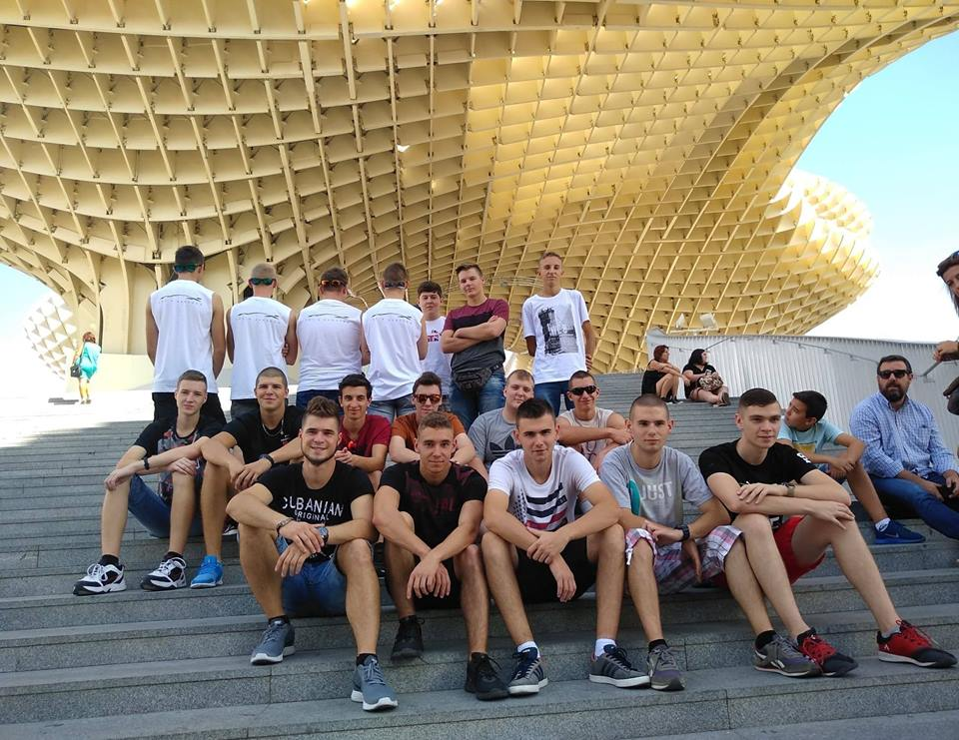
Maciej Byrtek
Host Organization: Eurotaller Alanis
Tutor’s name: Francisco Javier Alanis / Juan Luis Alanis
1. Description of the host organization
Eurotaller is a leading multi-brand automotive dealership belonging to the Group Auto Union which works with the latest technology, service and coverage to meet the needs of the users. They receive constant proposals from an important number of suppliers, offering the same product as well as delivery service, always at competitive prices.
2. Main responsibilities & tasks carried out during the work placement
- Helping with the installation and replacement of car air conditioning
- Assisting in aligning and repairing wheels
- Assisting in inspecting and testing new vehicles to detect potential faults
- Helping in lifting the vehicle to a specified level, using a hydraulic jack
- Disassembling units such as engines, gearbox etc. using manual or electric tools
3. Tutor’s final note
4. Tutor’s final evaluation
Very diligent trainee, able to carry out all of his tasks, even if they are very complicated. Demonstrates big potential to develop.
5. Participant’s opinion about his/her personal & professional development
My four weeks in Seville I spent mostly working. I learned a lot of new skills like wheel balancing or changing tires. People I worked with were very friendly and kind. We also had Spanish course on which I learned a lot. My free time I spent on getting to know Seville culture and manners. I would really like to come back to Seville in the future because I enjoyed whole time I spent here.
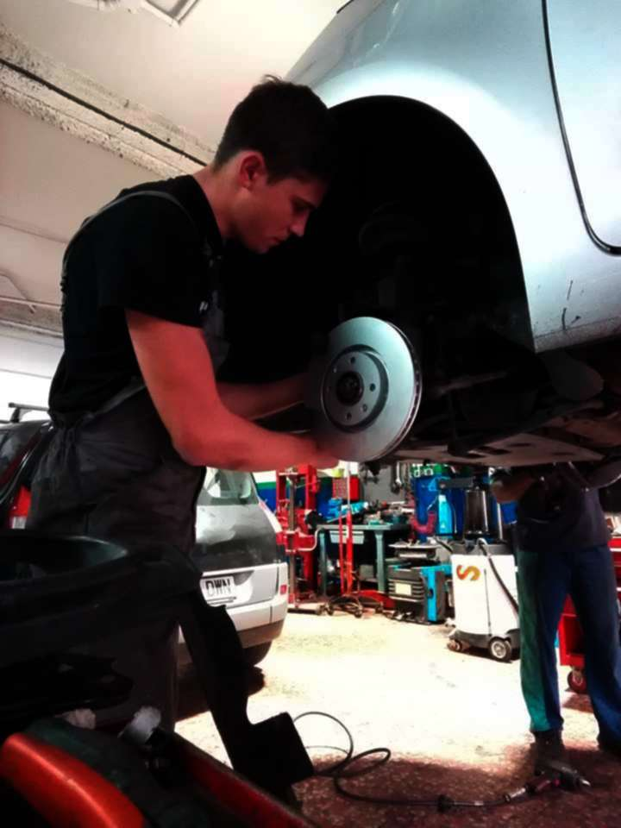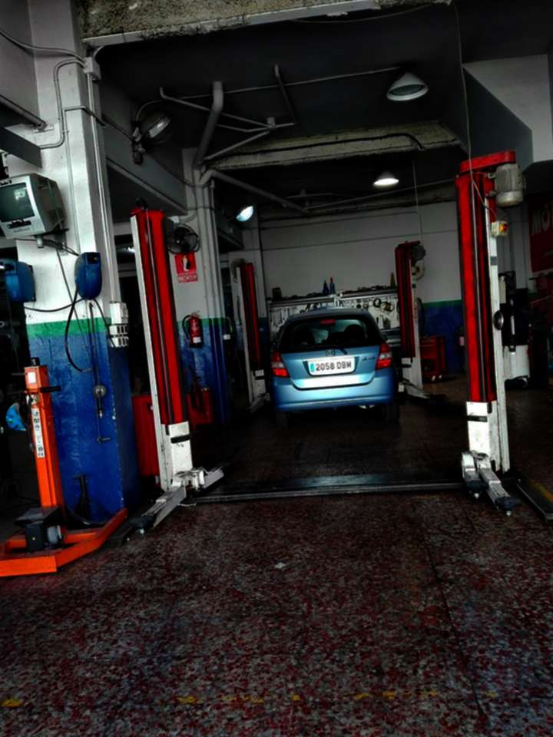
Tomasz Cieślar
Host Organization: Hotel Casa 1800
Tutor’s name:
1. Description of the host organization
Hotel Casa 1800 is located in the heart of Seville on Calle Rodrigo Caro 6, with fantastic views of the Cathedral and Giralda Tower from the terrace. The location is in the popular, lively and traditional area of the Santa Cruz district which was the old Jewish quarter of the city before the Catholic Reconquest.
2. Main responsibilities & tasks carried out during the work placement
- Learning to operate testing equipment to diagnose malfunctions
- Learning to test, diagnose and repair electronic circuit boards
- Performing preventive maintenance, cleaning and lubrication of electronic equipment
- Assisting in the installation of different systems
3. Tutor’s final note
4. Tutor’s final evaluation
I’m very content with results of his work.
5. Participant’s opinion about his/her personal & professional development
I spent four weeks mainly improving my skills related to the profession. In addition, I learned the new, foreign culture and beauty of Seville. It developed my personality and allowed me to develop and gain the necessary experience. I met new people and learned my language skills. I spent all my free time getting to know Sevilla with my friends.
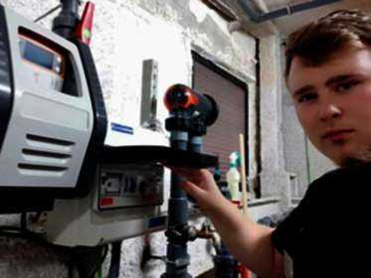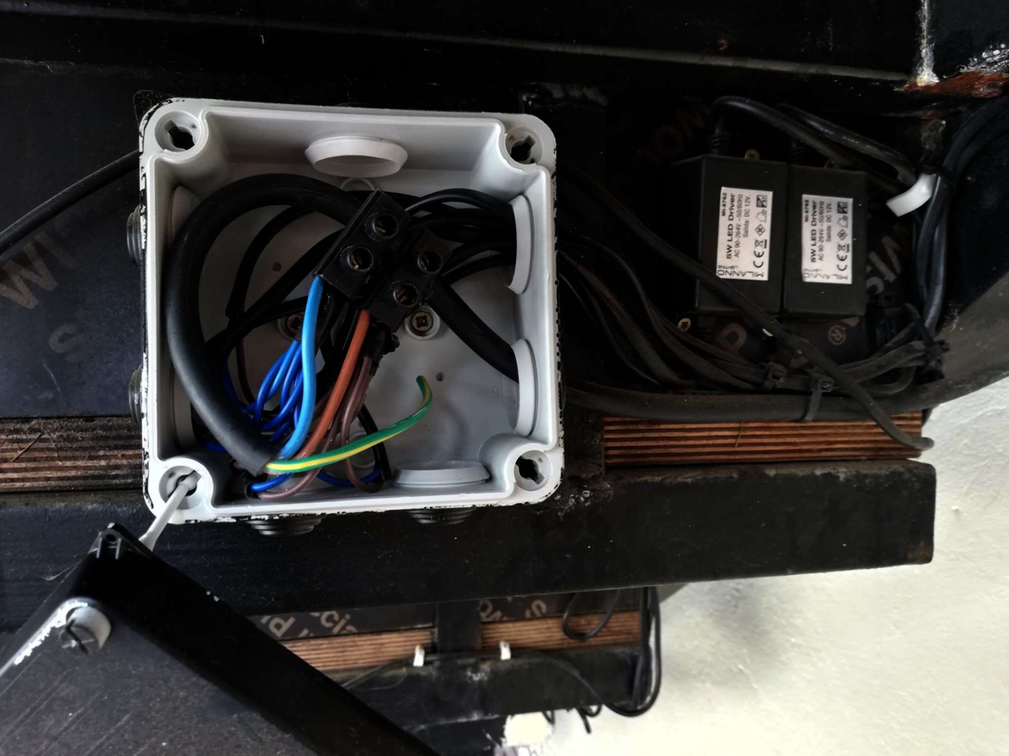

Kacper Gabzdyl
Host Organization: SKODA Cartuja Motor
Tutor’s name: José Luis Plaza Guerrero
1. Description of the host organization
Cartuja Motor was founded in 1985 as the first official dealer of Skoda in Seville and Huelva. Since then, their main goal has been to achieve the best customer satisfaction. The company ensures the highest levels of productivity and customer service.
2. Main responsibilities & tasks carried out during the work placement
- Helping with the installation and replacement of car air conditioning
- Assisting in aligning and repairing wheels
- Assisting in inspecting and testing new vehicles to detect potential faults
- Helping in lifting the vehicle to a specified level, using a hydraulic jack
- Disassembling units such as engines, gearbox etc. using manual or electric tools
- Performing basic services and repair activities related to car servicing, i.e. oil and filters change, defective parts replacement, washing of the engine and other car components
3. Tutor’s final note
4. Tutor’s final evaluation
Cooperates very well, very good worker.
5. Participant’s opinion about his/her personal & professional development
My visit in Spain was great. I had a great time and I could meet new people. At my work I improved my skills and I could learn a lot of new things. I have visited Malaga and Tavira. In my opinion Malaga is much better than Tavira, this city is so beautiful.
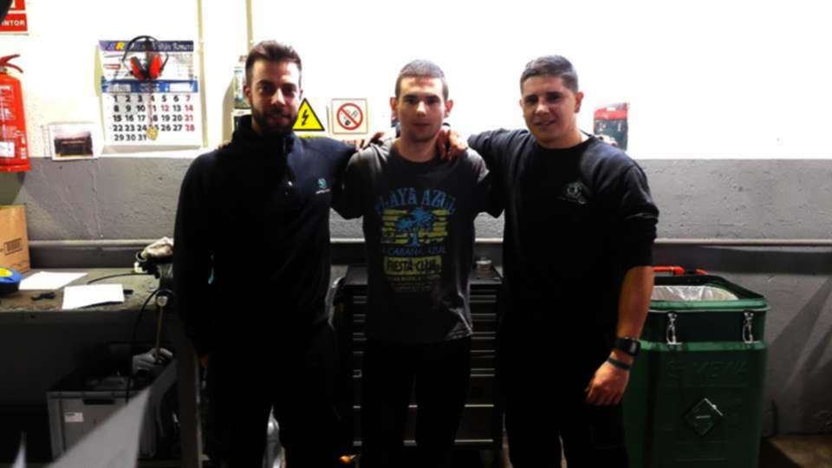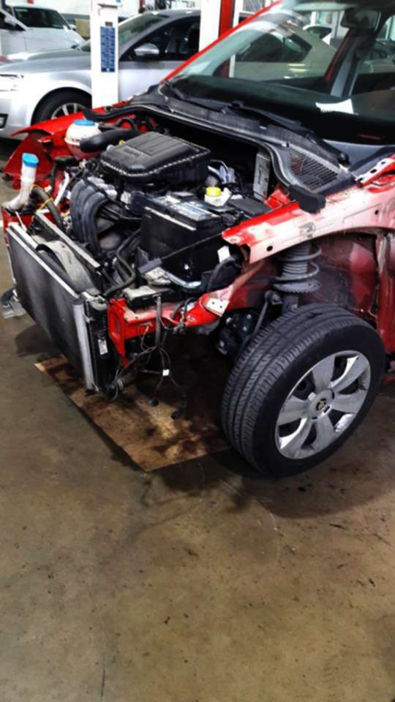

Dominik Kohut
Host Organization: Servicio Técnico J.Capi - Jorge Sanchez Capita
Tutor’s name: Jorge Sanchez Capita
1. Description of the host organization
Jorge Capi Technical Service is a family company founded in 1983. The company is dedicated to the repair and sale of electrical appliances, air conditioning equipment and hospitality machinery in the town of Alcalá de Guadaíra, just half an hour by bus from the capital of Andalusia. The company has more than 30 years of experience and this has allowed their staff to achieve high levels of service and a good reputation on the market. Jorge Capi Technical Service values its clients and works constantly to improve the quality of all the services offered.
2. Main responsibilities & tasks carried out during the work placement
- Learning how to operate test equipment to diagnose malfunctions
- Performing tests, diagnosing and repairing electronic circuit boards
- Performing preventive maintenance, cleaning, and lubrication of electronics equipment
- Assisting in the installations of different systems
3. Tutor’s final note
4. Tutor’s final evaluation
Very good worker, diligent and persistent!
5. Participant’s opinion about his/her personal & professional development
During my internship in Spain, I got to know a new culture and customs. I developed my skills, among others, in the repair of electronic circuits, location of the causes of device failures. I also saw what elements fail the most often.
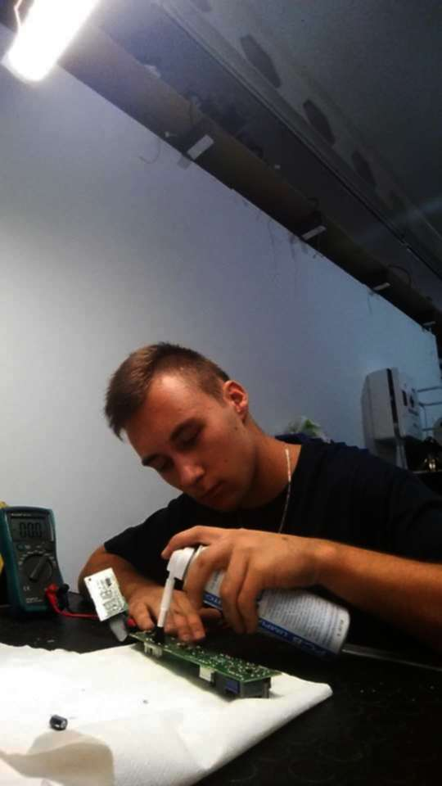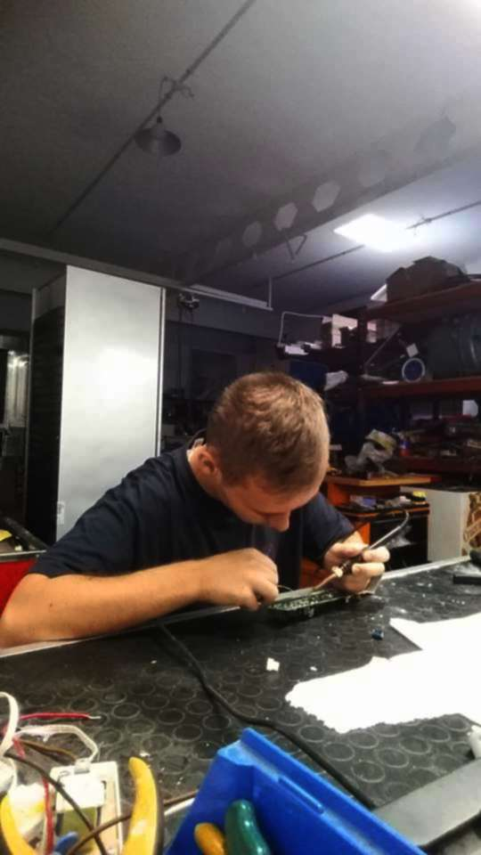
Kamil Król
Host Organization: Abastec
Tutor’s name: Daniel Florido Serrano
1. Description of the host organization
Abastec is an electronics company that mainly repairs household appliances and sells spare parts. It was founded in 1987 and has two shops in Seville that are located in two strategic areas to provide better service and attention to its clients: Avenida Miraflores (Macarena neighbourhood) and Calle Pages del Corro (Triana neighbourhood).
2. Main responsibilities & tasks carried out during the work placement
- Learning to operate testing equipment to diagnose malfunctions
- Learning to test, diagnose and repair electronic circuit boards
- Performing preventive maintenance, cleaning and lubrication of electronic equipment
- Assisting in the installation of different systems
3. Tutor’s final note
4. Tutor’s final evaluation
Needs to improve.
5. Participant’s opinion about his/her personal & professional development
During my one-month stay in sunny Seville, I learned a lot of things related to my future profession. I improved the soldering skills and Ive learned how to repair many electronic devices. While participating in many trips, I got to know the local culture, which turned out to be extremely interesting.
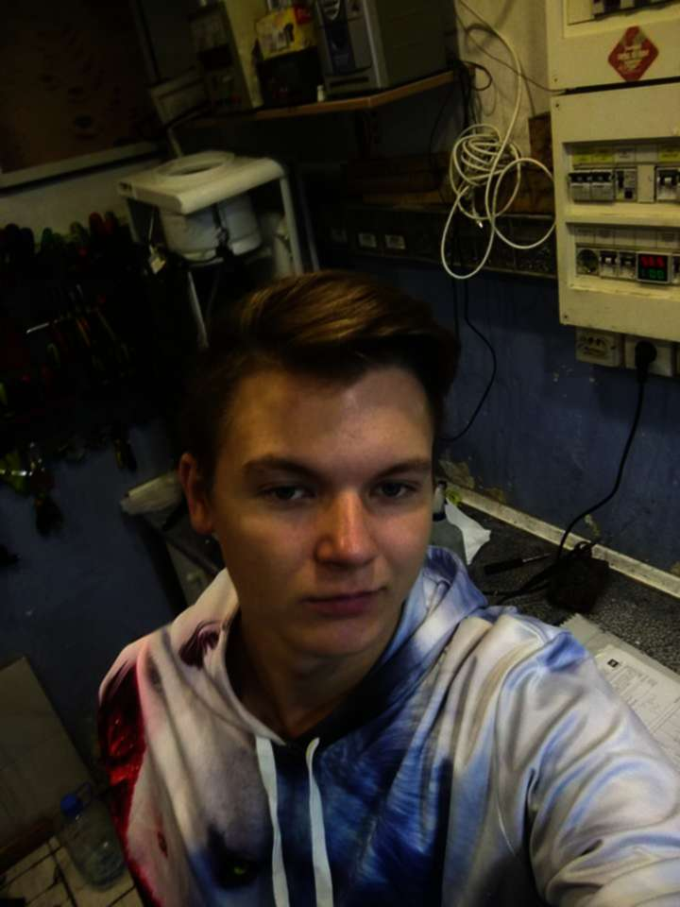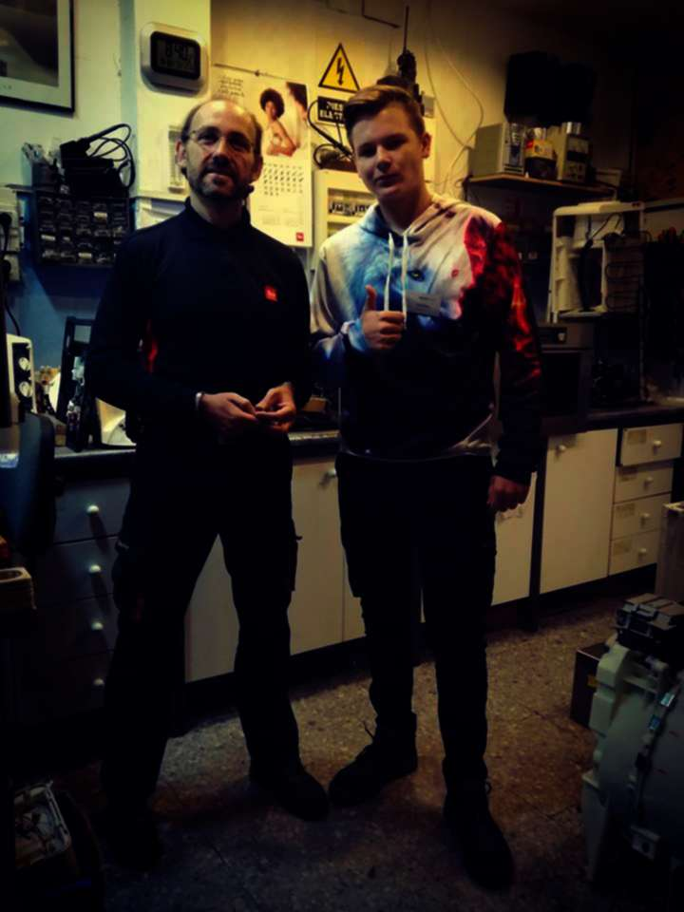
Szymon Madecki
Host Organization: HGM Sevilla
Tutor’s name: Francisco Garrido
1. Description of the host organization
HGM Sevilla is a family-owned company located in Seville, in Los Remedios headquarter. It is situated on Calle Virgen de Lujan, famous for its cooking and dining stores as well as clothes and shoe shops. It is a small and very well- known company in the district which works with individual customers and enterprises. HGM offers a top quality service and technical support to its customers and partners dealing with reparation and maintenance of different kinds of electronic devices.
2. Main responsibilities & tasks carried out during the work placement
- Learning to operate testing equipment to diagnose malfunctions
- Learning to test, diagnose and repair electronic circuit boards
- Performing preventive maintenance, cleaning and lubrication of electronic equipment
- Assisting in the installation of different systems
3. Tutor’s final note
4. Tutor’s final evaluation
Very responsible trainee. He is punctual and carries out his tasks on time.
5. Participant’s opinion about his/her personal & professional development
During my one month stay in sunny Seville I learned a lot of things related to my profession.
I improved the soldering skills. I have learned to repair many electronic and electrical devices.
Taking part in trips, I got to know the local culture, which turned out to be very interesting.
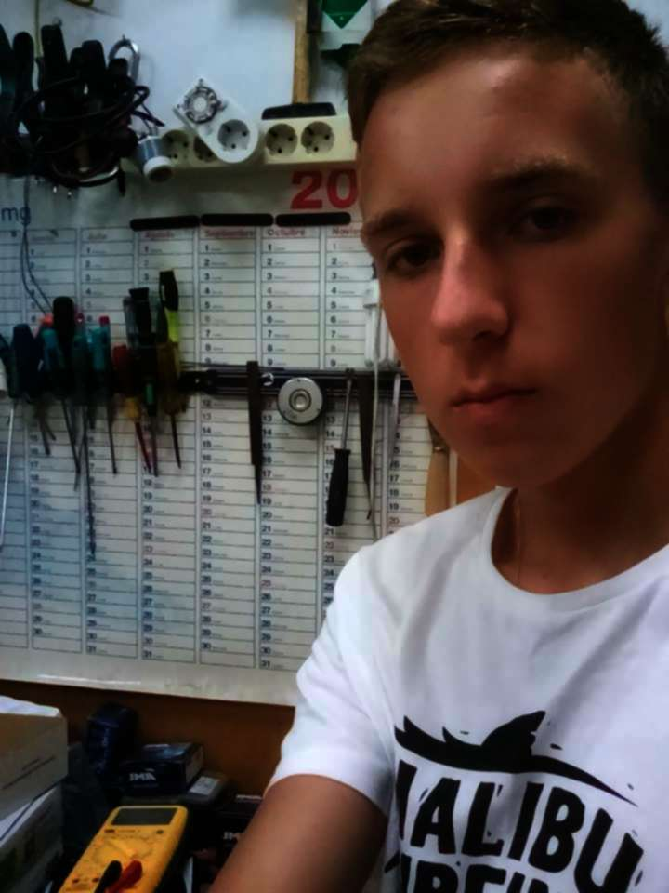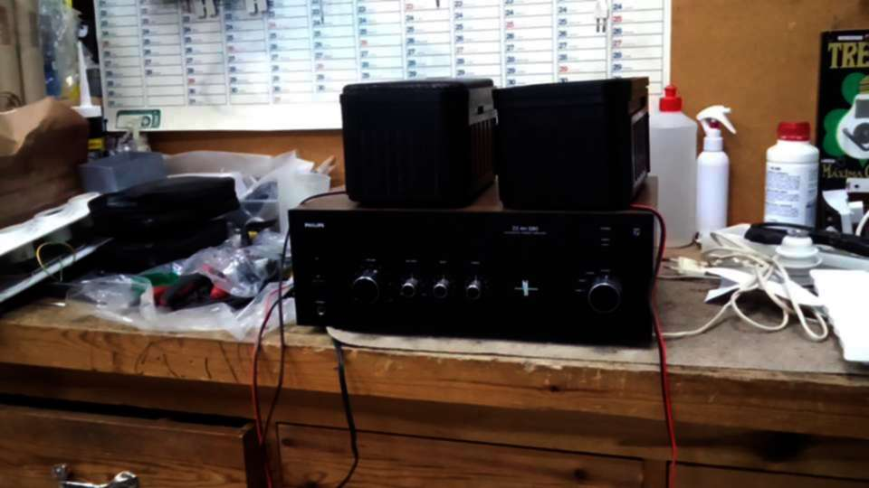
Michał Madzia
Host Organization: SKODA Cartuja Motor
Tutor’s name: José Luis Plaza Guerrero
1. Description of the host organization
Cartuja Motor was founded in 1985 as the first official dealer of Skoda in Seville and Huelva. Since then, their main goal has been to achieve the best customer satisfaction. The company ensures the highest levels of productivity and customer service, and this is what makes them the best dealer within the Skoda network. Cartuja Motor also provides exclusive Volkswagen services, counting on the latest technical information by Volkswagen-Audi group.
2. Main responsibilities & tasks carried out during the work placement
- Helping with the installation and replacement of car air conditioning
- Assisting in aligning and repairing wheels
- Assisting in inspecting and testing new vehicles to detect potential faults
- Helping in lifting the vehicle to a specified level, using a hydraulic jack
- Disassembling units such as engines, gearbox etc. using manual or electric tools
3. Tutor’s final note
4. Tutor’s final evaluation
He’s a very diligent and punctual worker.
5. Participant’s opinion about his/her personal & professional development
I think my stay in Spain is successful. Ive learned news things, change oil, change filtr. I have traveled a lot and learned about Spain. I was on the island of Tavira and on the beach in Malaga.

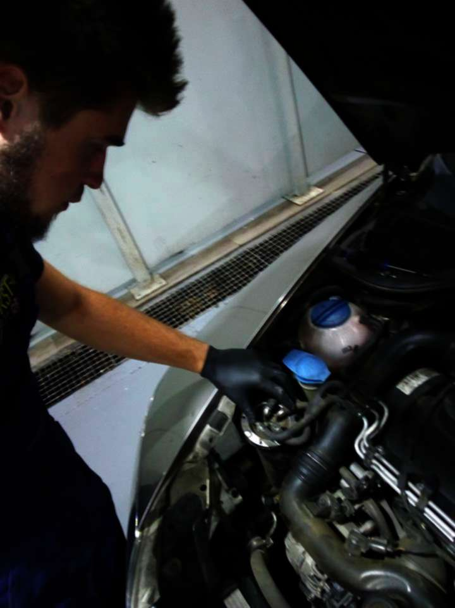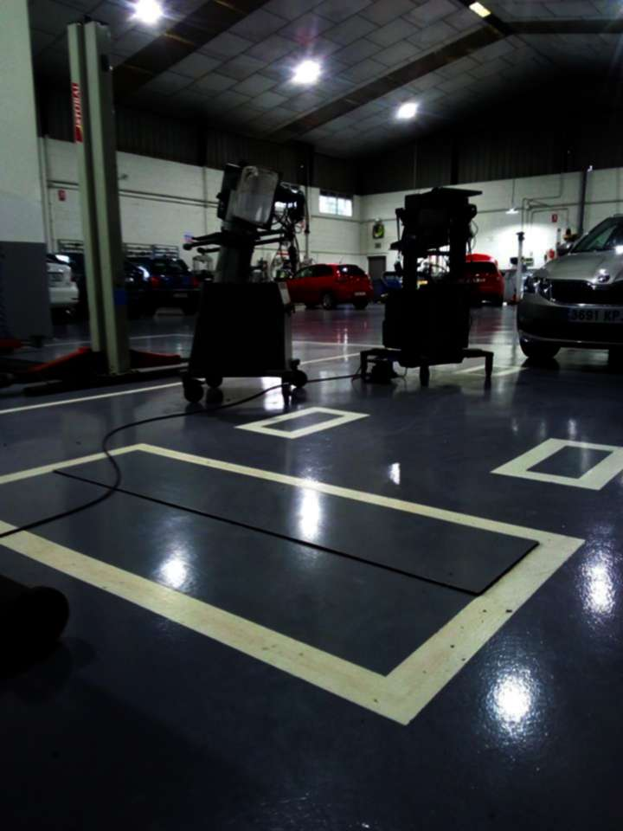
Adam Malina
Host Organization: Talleres Morales y Molero S.L.
Tutor’s name: David Morales Osuna
1. Description of the host organization
Eurotaller is a leading, multi-brand auto repair shop that works with a lot of car brands with technological innovations and provides a full range of services to meet the needs of its clients. They are open for any chance to modernize and increase knowledge of the car mechanic sector.
2. Main responsibilities & tasks carried out during the work placement
- Helping with the installation and replacement of car air conditioning
- Assisting in aligning and repairing wheels
- Assisting in inspecting and testing new vehicles to detect potential faults
- Helping in lifting the vehicle to a specified level, using a hydraulic jack
- Disassembling units such as engines, gearbox etc. using manual or electric tools
3. Tutor’s final note
4. Tutor’s final evaluation
Very responsible trainee. He is punctual and carries out his tasks on time.
5. Participant’s opinion about his/her personal & professional development
During my stay in Spain I liked the trips that showed us culture and history of the state in which we were. In this project, the main goal was to teach us the profession we chose while going to the technical for the class that interested us. My work was great for me because I could meet new people and learn the profession I want to do in the future.

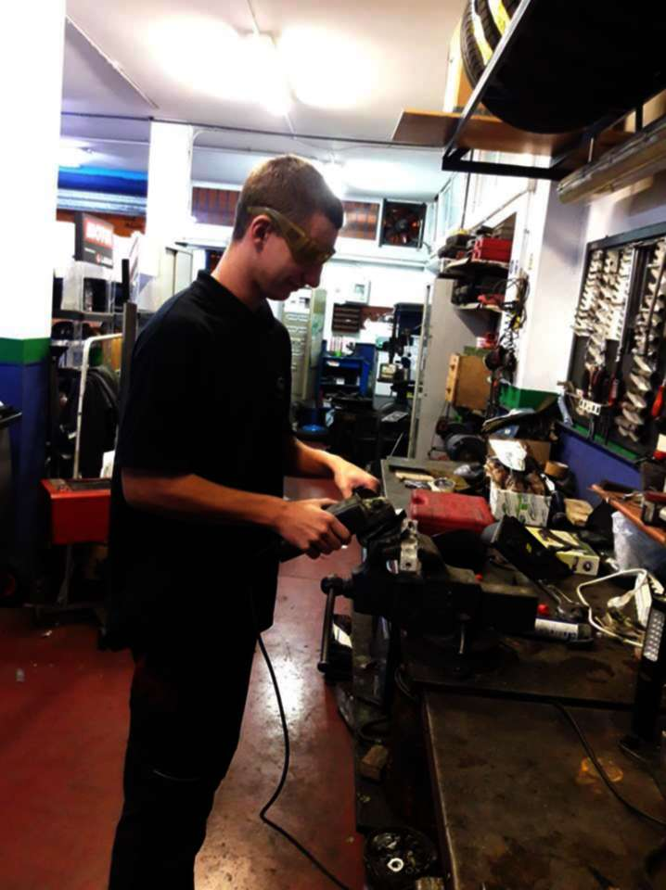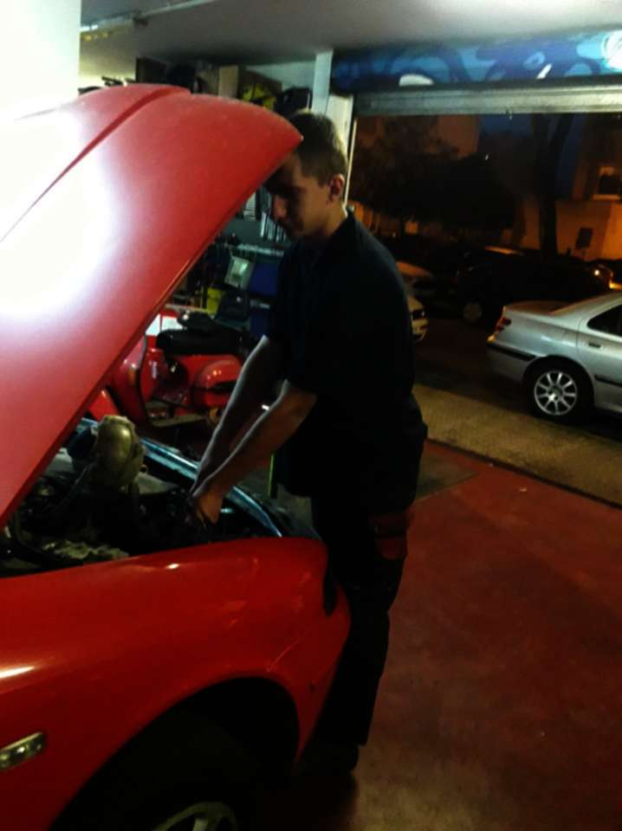
Łukasz Martynek
Host Organization: Talleres Cabezuelo S.L.
Tutor’s name: Alfonso Cabezuelo Gonzalez
1. Description of the host organization
Talleres Cabezuelo is located in Cerro del Aguila neighbourhood, precisely on Calle Diamantino García Acosta 38. The Cabezuelo workshop is a high-quality workshop thanks to its team with a lot of experience working together in the car's market. They carry out general mechanical work and also conventional body and paintwork. Talleres Cabezuelo’s team is totally trustworthy.
2. Main responsibilities & tasks carried out during the work placement
- Helping with the installation and replacement of car air conditioning
- Assisting in aligning and repairing wheels
- Assisting in inspecting and testing new vehicles to detect potential faults
- Helping in lifting the vehicle to a specified level, using a hydraulic jack
- Disassembling units such as engines, gearbox etc. using manual or electric tools
3. Tutor’s final note
4. Tutor’s final evaluation
I’m very content with results of his work.
5. Participant’s opinion about his/her personal & professional development
I really enjoyed travel to Spain. I learned a lot of things, such as vulcanization and patching tires, wheel alignment etc. At work it was nice and warmly received me. I met many people and learned language a little. The trips were interesting and we visited nice places. I evaluate the trip positively.

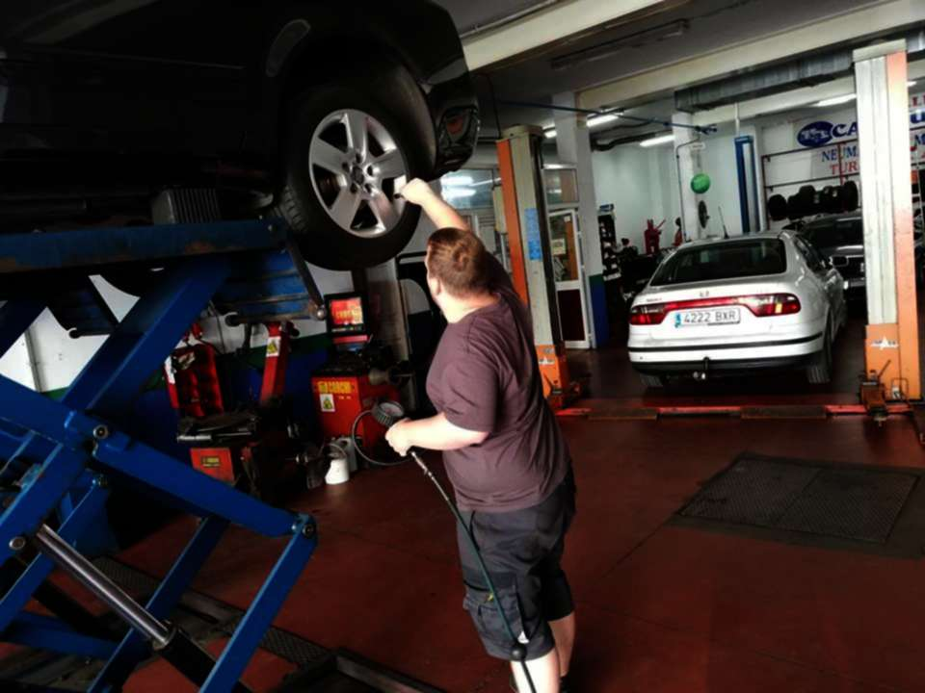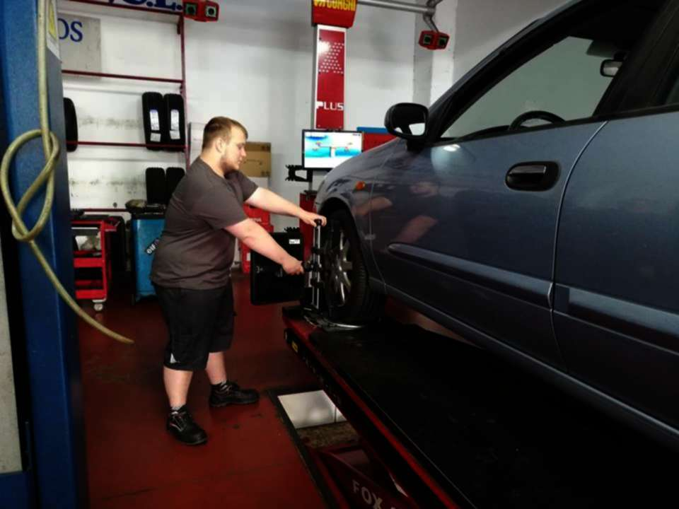

Marcel Nawrat
Host Organization: EME Catedral Hotel
Tutor’s name: Marita Jiménez
1. Description of the host organization
EME Catedral is a Boutique Hotel which is located in the historical centre of Seville, in the Santa Cruz neighbourhood, right in front of the Cathedral and the Giralda, just a small walk away from the shopping area. The building is the result of the restoration of fourteen typical Sevillian houses from the sixteenth century.
2. Main responsibilities & tasks carried out during the work placement
- Learning to operate testing equipment to diagnose malfunctions
- Learning to test, diagnose and repair electronic circuit boards
- Performing preventive maintenance, cleaning and lubricating an electronic equipment
- Assisting in the installation of different systems
- Testing newly acquired equipment for functioning ability
3. Tutor’s final note
4. Tutor’s final evaluation
Well prepared and good observant, pays attention to his work all the time.
5. Participant’s opinion about his/her personal & professional development
Ive learned a lot of new things here. Among other things, replace air conditioning filters, repair 24V power supply and refrigerators. There was a nice and friendly atmosphere at work. I also got to know a new culture. I really liked the local climate and would like to come back here one day.
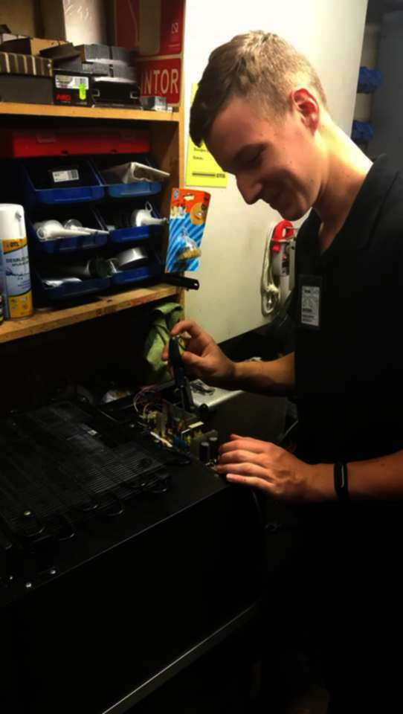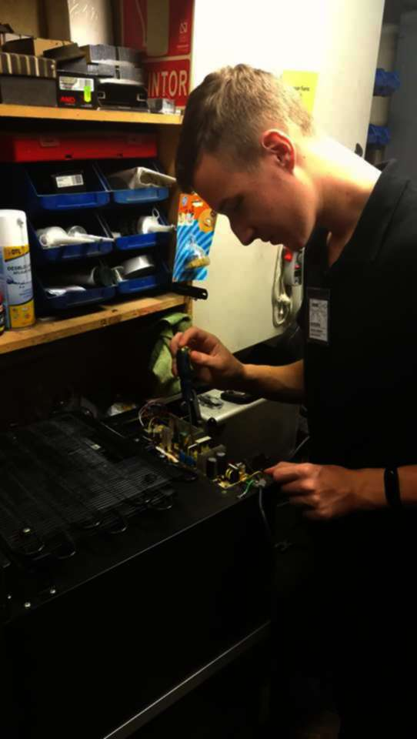
Paweł Pałka
Host Organization: Talleres Morales y Molero S.L.
Tutor’s name: David Morales Osuna

1. Description of the host organization
Eurotaller is a leading, multi-brand auto repair shop that works with a lot of car brands with technological innovations and provides a full range of services to meet the needs of its clients. They are open for any chance to modernize and increase knowledge of the car mechanic sector
2. Main responsibilities & tasks carried out during the work placement
- Helping with the installation and replacement of car air conditioning
- Assisting in aligning and repairing wheels
- Assisting in inspecting and testing new vehicles to detect potential faults
- Helping in lifting the vehicle to a specified level, using a hydraulic jack
- Disassembling units such as engines, gearbox etc. using manual or electric tools
3. Tutor’s final note
4. Tutor’s final evaluation
Very responsible trainee. He is punctual and carries out his tasks on time.
5. Participant’s opinion about his/her personal & professional development
While I being in Spain I spend a lot of beautiful moments and I have learned few new things thanks to work. During visit in Spain I met a new culture. In my workplace people I worked with were very kind and friendly. After work we visited a lot of monuments and places.
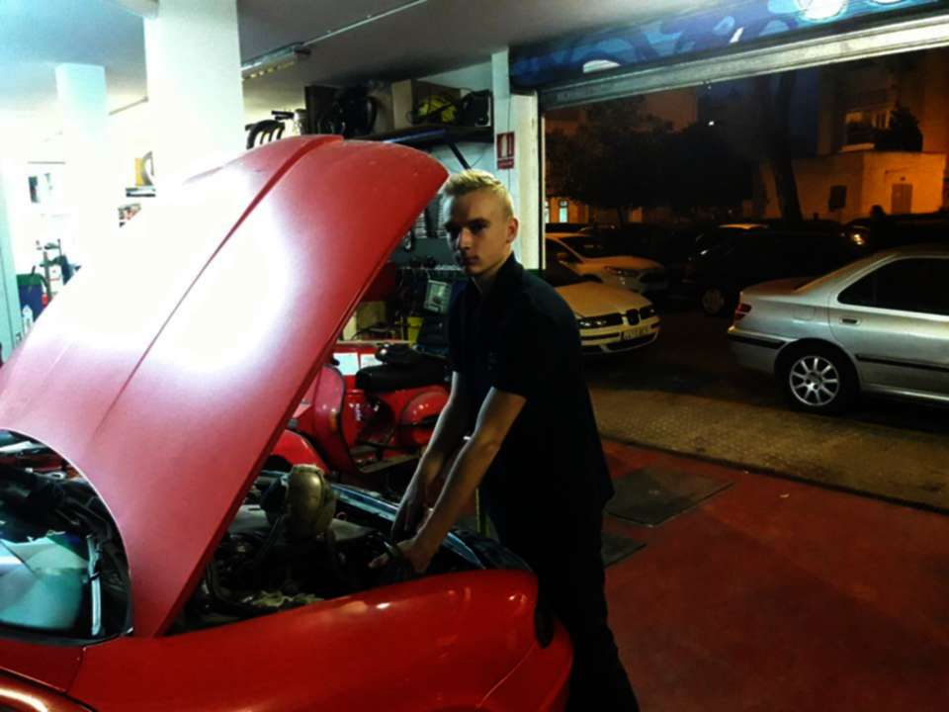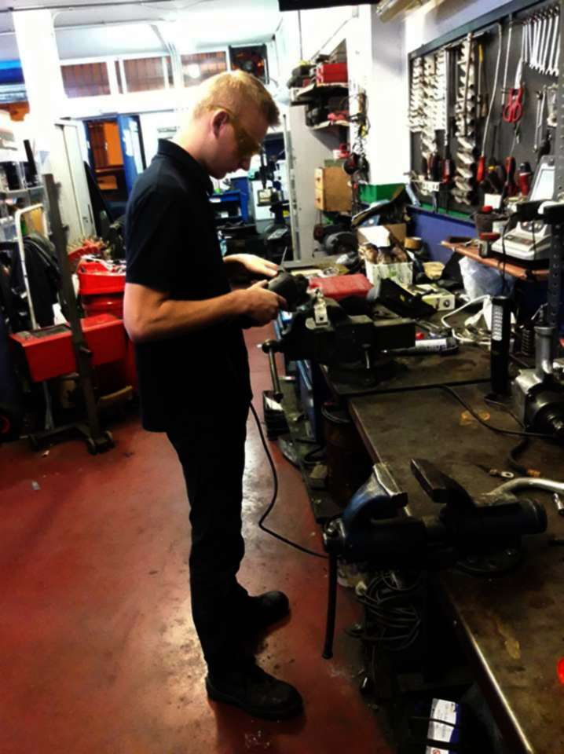
Jakub Pietrasina
Host Organization: EME Catedral Hotel
Tutor’s name: Marita Jiménez
1. Description of the host organization
EME Catedral is a Boutique Hotel which is located in the historical centre of Seville, in the Santa Cruz neighbourhood, right in front of the Cathedral and the Giralda, just a small walk away from the shopping area. The building is the result of the restoration of fourteen typical Sevillian houses from the sixteenth century.
2. Main responsibilities & tasks carried out during the work placement
- Learning to operate testing equipment to diagnose malfunctions
- Learning to test, diagnose and repair electronic circuit boards
- Performing preventive maintenance, cleaning and lubricating an electronic equipment
- Assisting in the installation of different systems
3. Tutor’s final note
4. Tutor’s final evaluation
Very good worker, very active and willing to do his tasks.
5. Participant’s opinion about his/her personal & professional development
In Spain, on practices, I learned a lot of interesting things related to electronics. We had very nice atmosphere at work, everyone walked in smiling and asked how I was working. I also got to know the local culture and try Spanish dishes.

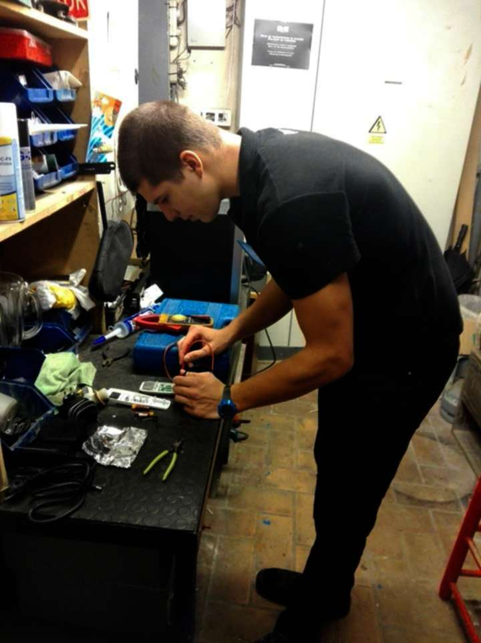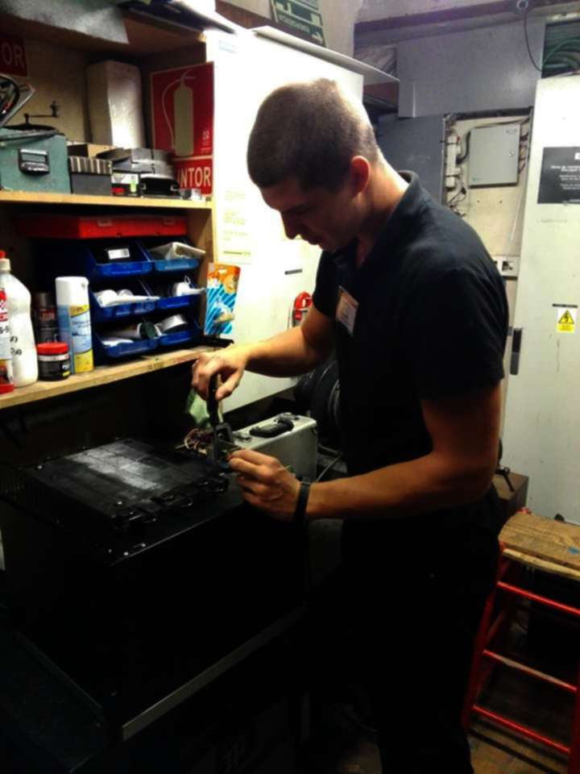
Bartłomiej Sidzina
Host Organization: Fiat Italian Motor Village
Tutor’s name: Juan Martinez Garcia

1. Description of the host organization
The Fiat Italian Motor Village workshop works on the basis of a dealership agreement with Fiat S.p.A. FIAT (Italian: Fabbrica Italiana Automobili Torino, Italian Automobiles Factory, Turin). It is an Italian car maker which produces Fiat branded cars and it is part of Fiat Chrysler Automobiles through its subsidiary FCA Italy S.p.A. which is the largest automobile manufacturer in Italy.
2. Main responsibilities & tasks carried out during the work placement
- Helping with the installation and replacement of car air conditioning
- Assisting in aligning and repairing wheels
- Assisting in inspecting and testing new vehicles to detect potential faults
- Helping in lifting the vehicle to a specified level, using a hydraulic jack
- Disassembling units such as engines, gearbox etc. using manual or electric tools
- Performing basic services and repair activities related to car servicing, i.e. oil and filters change, defective parts replacement, washing of the engine and other car components
3. Tutor’s final note
4. Tutor’s final evaluation
Diligent trainee. We’re satisfied with his work.
5. Participant’s opinion about his/her personal & professional development
During my stay in Spain I have learnt many interested things such as car service, replacement of various parts, correct diagnostic etc. Workshops had very nice atmosphere and teamwork.
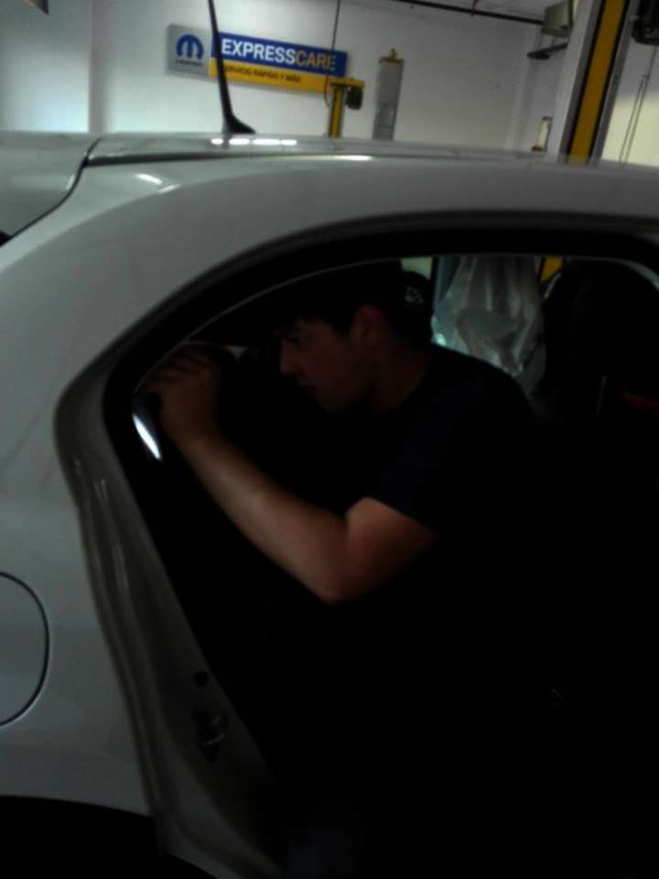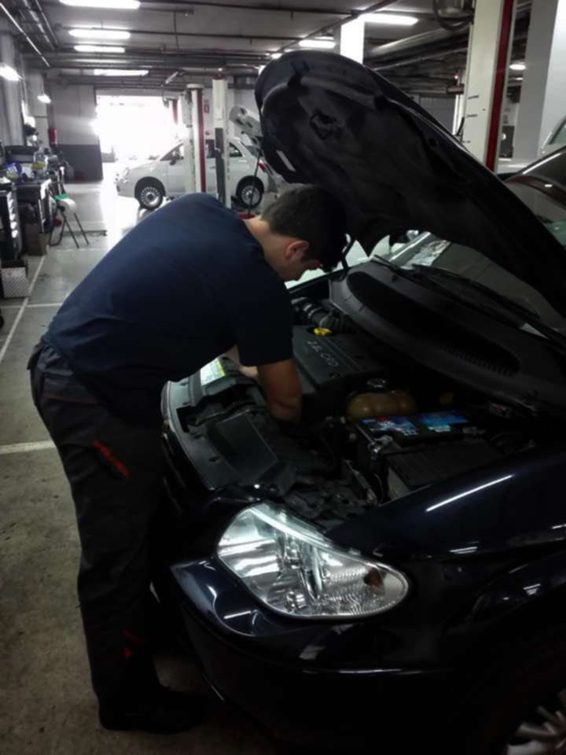

Łukasz Sikora
Host Organization: Talleres y Lavados Laven - Francisco Javier Lopez Alagaba
Tutor’s name: Francisco Javier Lopez Algaba
1. Description of the host organization
Talleres y Lavados Laven is a workshop dedicated to the general mechanics and electrics of cars, cleaning of all types of car, upholstery maintenance, headlights polishing, window tinting, wheel and hubcap maintenance and they also rent spaces in their garage. It owns almost 600 m2 of work space.
2. Main responsibilities & tasks carried out during the work placement
- Helping with the installation and replacement of car air conditioning
- Assisting in aligning and repairing wheels
- Assisting in inspecting and testing new vehicles to detect potential faults
- Helping in lifting the vehicle to a specified level, using a hydraulic jack
- Disassembling units such as engines, gearbox etc. using manual or electric tools
3. Tutor’s final note
4. Tutor’s final evaluation
Very obedient and accurate worker.
5. Participant’s opinion about his/her personal & professional development
During my job practice, I have learned how to work in a team and communicate with the foreigners. I have developed my skills as a car mechanic. I have found out the culture of another country. I acquired the skills to find myself in a new environment.
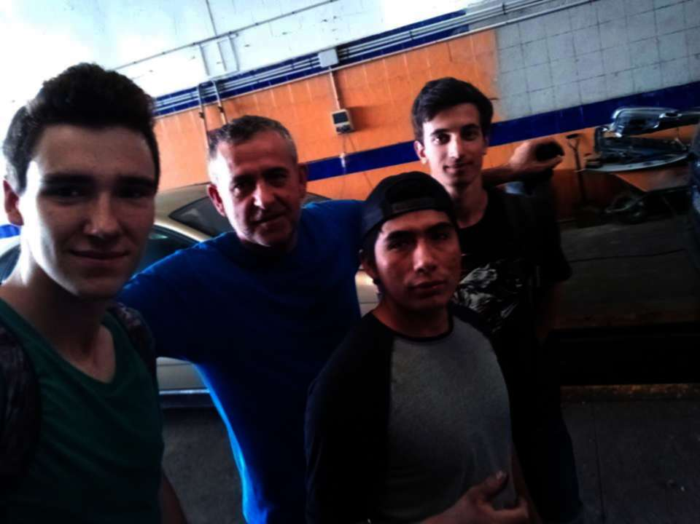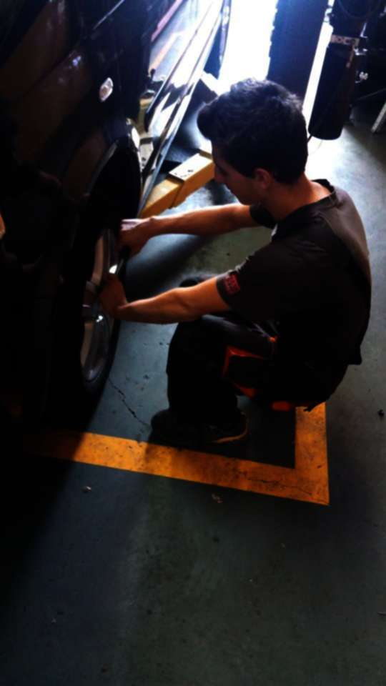

Damian Stebel
Host Organization: Talleres y Lavados Laven - Francisco Javier Lopez Alagaba
Tutor’s name: Francisco Javier Lopez Algaba
1. Description of the host organization
Lavados Laven is a workshop dedicated to the general mechanics and electrics of cars, cleaning of all types of car, upholstery maintenance, headlights polishing, window tinting, wheel and hubcap maintenance and they also rent spaces in their garage. It owns almost 600 m2 of work space.
2. Main responsibilities & tasks carried out during the work placement
- Helping with the installation and replacement of car air conditioning
- Assisting in aligning and repairing wheels
- Assisting in inspecting and testing new vehicles to detect potential faults
- Helping in lifting the vehicle to a specified level, using a hydraulic jack
- Disassembling units such as engines, gearbox etc. using manual or electric tools
3. Tutor’s final note
4. Tutor’s final evaluation
Takes his work seriously, good behavior, obedient.
5. Participant’s opinion about his/her personal & professional development
I learned a lot of useful things e.g. car mechanics in practice and how to apply the knowledge acquired at school. I have explored new culture I have never seen before. I´ve trained in English but I´ve also learned to communicate with people who do not know my language. ´The atmosphere at work was nice thanks to bosses and co-workers. I was very pleased to be welcomed and accepted by my colleagues. Working with them was one of the most beautiful things I could ever expect.
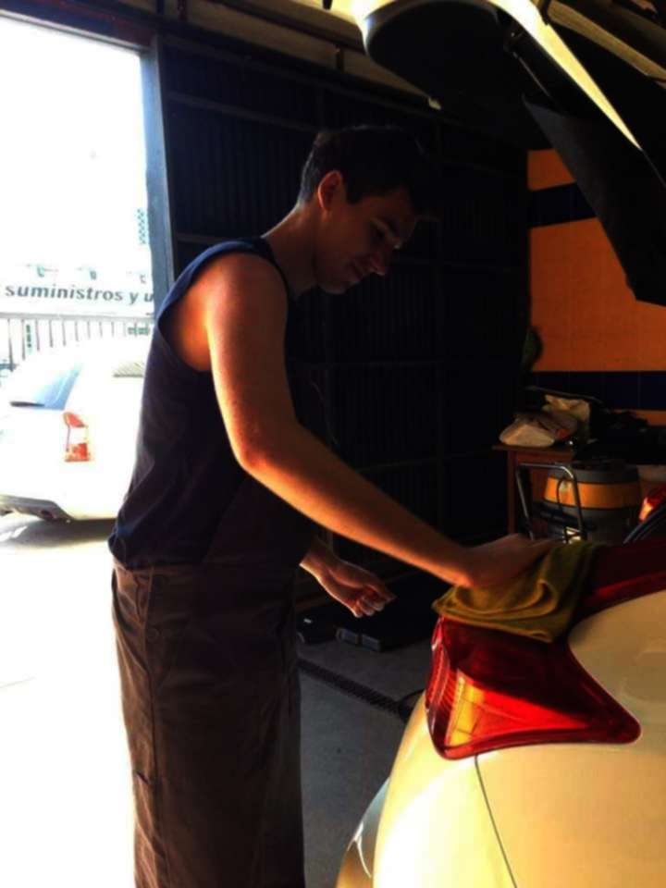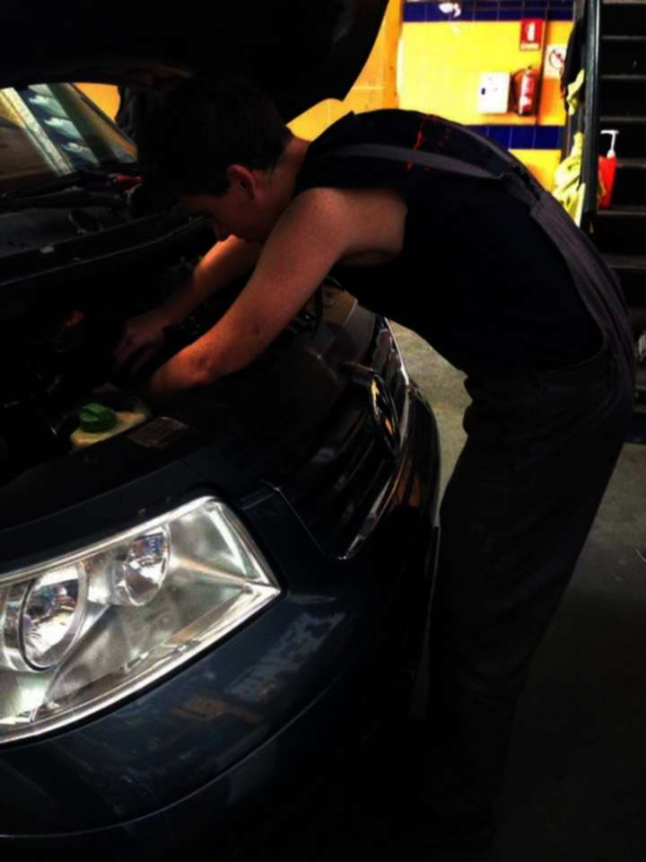

Marcin Surmiak
Host Organization: DTV Urquiza
Tutor’s name: Jose Guerrero Romero

1. Description of the host organization
The DTV Urquiza store is dedicated to repairing sound and video equipment, PC and small appliances. DTV Urquisa offers JVC official service and they also repair other brands, such as Toshiba, Sony, Panasonic, LG, Philips, Canon and much more. They make budgets without compromise and offer a guarantee on all repairs, including those for computers and digital cameras.
2. Main responsibilities & tasks carried out during the work placement
- Learning to operate testing equipment to diagnose malfunctions
- Learning to test, diagnose and repair electronic circuit boards
- Performing preventive maintenance, cleaning and lubrication of electronic equipment
- Assisting in the installation of different systems
3. Tutor’s final note
4. Tutor’s final evaluation
I’d recommend him to any company. Very good worker.
5. Participant’s opinion about his/her personal & professional development
The atmosphere was great and I have learned a lot. I met nice people and it was fun to spend time with them. I visited a lot of beautiful places and stay in Spain was very interesting.

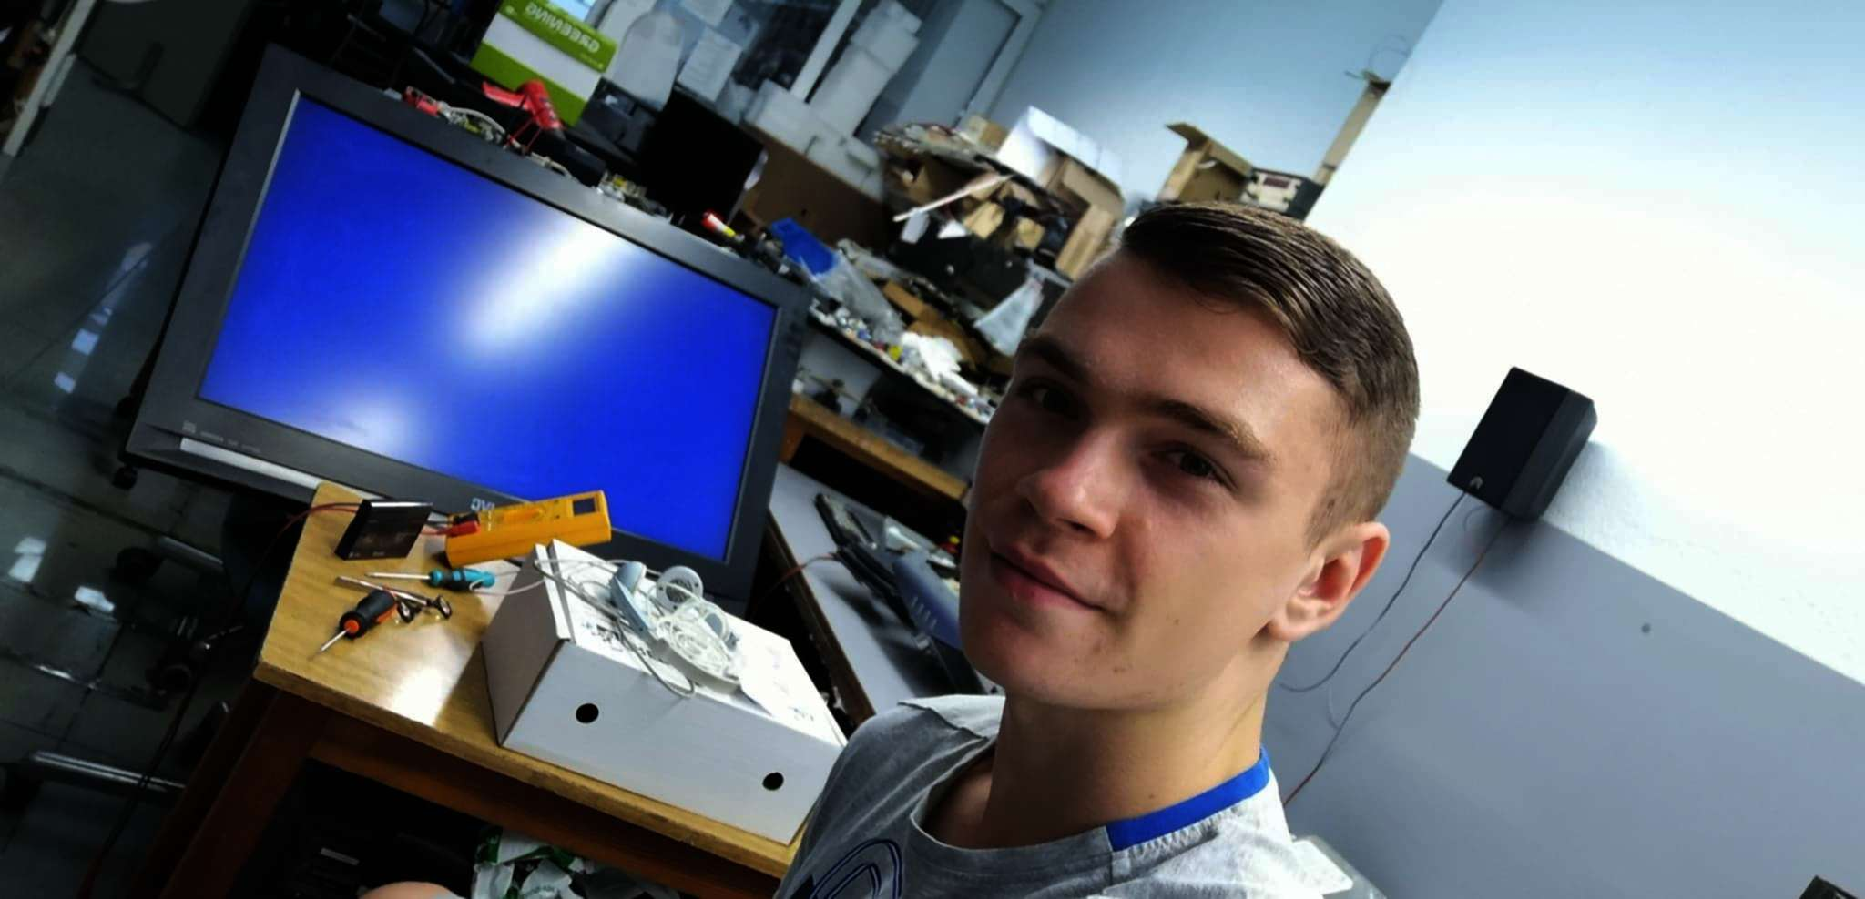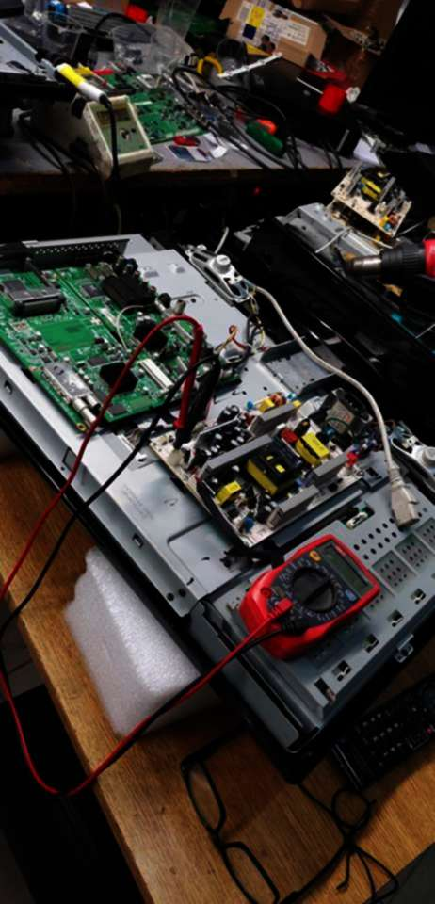

Krzysztof Szworc
Host Organization: Abastec
Tutor’s name: Daniel Florido Serrano
1. Description of the host organization
Abastec is an electronics company that mainly repairs household appliances and sells spare parts. It was founded in 1987 and has two shops in Seville that are located in two strategic areas to provide better service and attention to its clients: Avenida Miraflores (Macarena neighbourhood) and Calle Pages del Corro (Triana neighbourhood). The company has a lot of experience in white goods and A.P.E.
2. Main responsibilities & tasks carried out during the work placement
- Learning to operate testing equipment to diagnose malfunctions
- Learning to test, diagnose and repair electronic circuit boards
- Performing preventive maintenance, cleaning and lubrication of electronic equipment
- Assisting in the installation of different systems
3. Tutor’s final note
4. Tutor’s final evaluation
Has a wide knowledge and pays attention to his work.
5. Participant’s opinion about his/her personal & professional development
I gained many useful skills during my practices in Spain, for example how to find mistakes in damaged devices, how to properly solder. At work, I met a lot of nice and friendly people who always helped me. During my stay in spain I saw many beautiful places and experienced many interesting attractions. these practices have been an amazing experience.
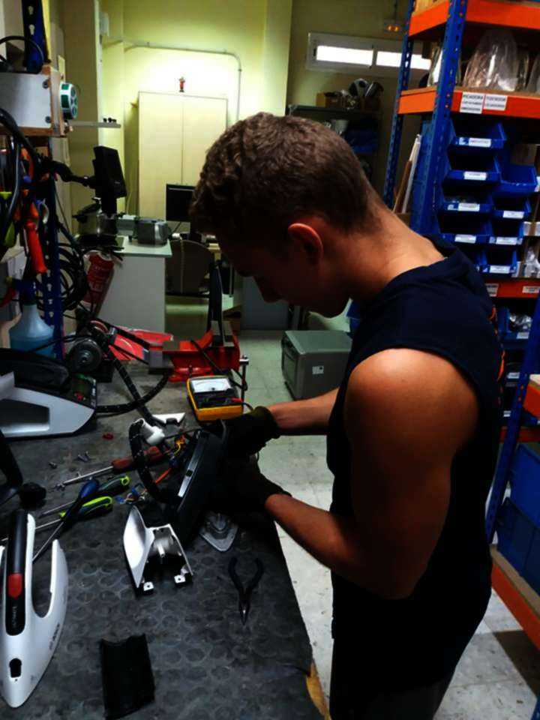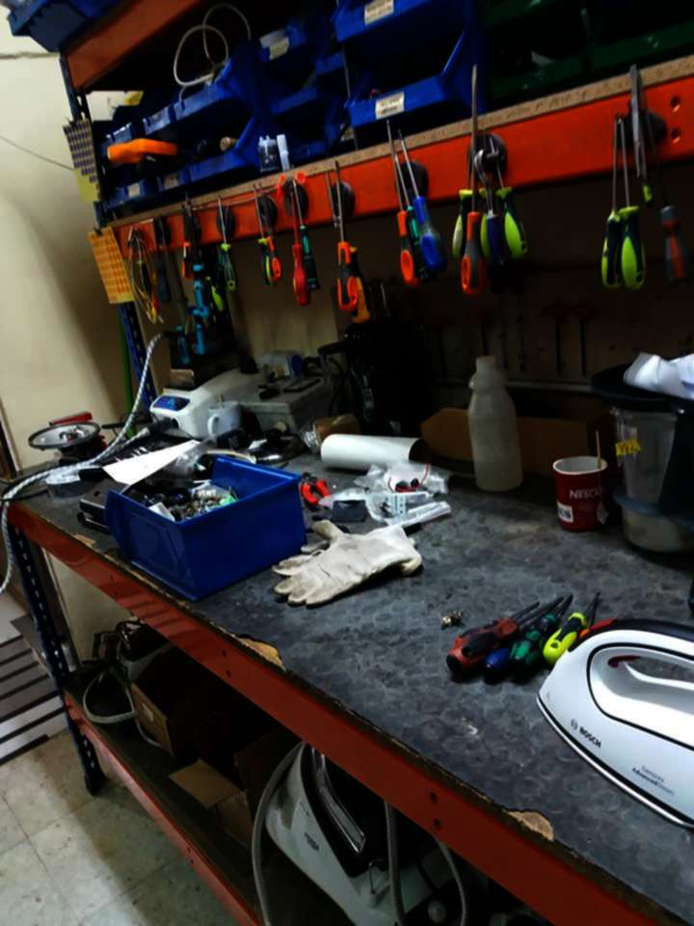

Michał Szyndler
Host Organization: Fiat Italian Motor Village
Tutor’s name: Juan Martinez Garcia

1. Description of the host organization
The Fiat Italian Motor Village workshop works on the basis of a dealership agreement with Fiat S.p.A. FIAT (Italian: Fabbrica Italiana Automobili Torino, Italian Automobiles Factory, Turin). It is an Italian car maker which produces Fiat branded cars and it is part of Fiat Chrysler Automobiles through its subsidiary FCA Italy S.p.A. which is the largest automobile manufacturer in Italy.
2. Main responsibilities & tasks carried out during the work placement
- Helping with the installation and replacement of car air conditioning
- Assisting in aligning and repairing wheels
- Assisting in inspecting and testing new vehicles to detect potential faults
- Helping in lifting the vehicle to a specified level, using a hydraulic jack
- Disassembling units such as engines, gearbox etc. using manual or electric tools
3. Tutor’s final note
4. Tutor’s final evaluation
Szyndler – Diligent trainee. We’re satisfied with his work.
18. Participant’s opinion about his/her personal & professional development
During practise I have learned a lot. I met new tools and I have learned how to use them. The atmosphere at work was very pleasant. I visited some attractions in Spain. I got acquainted with the Spanish culture I think it is a good trip.
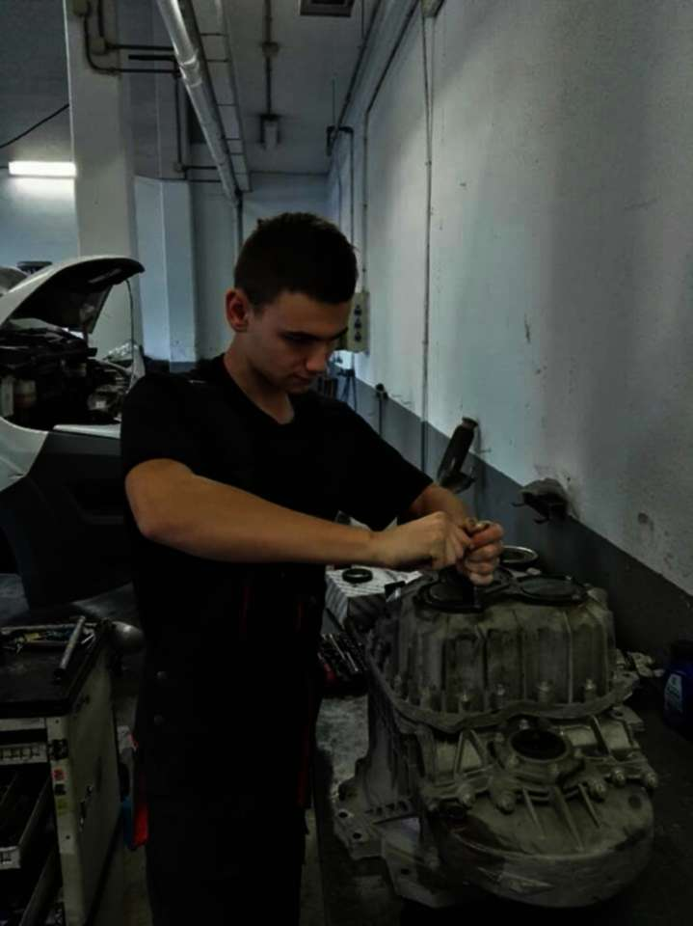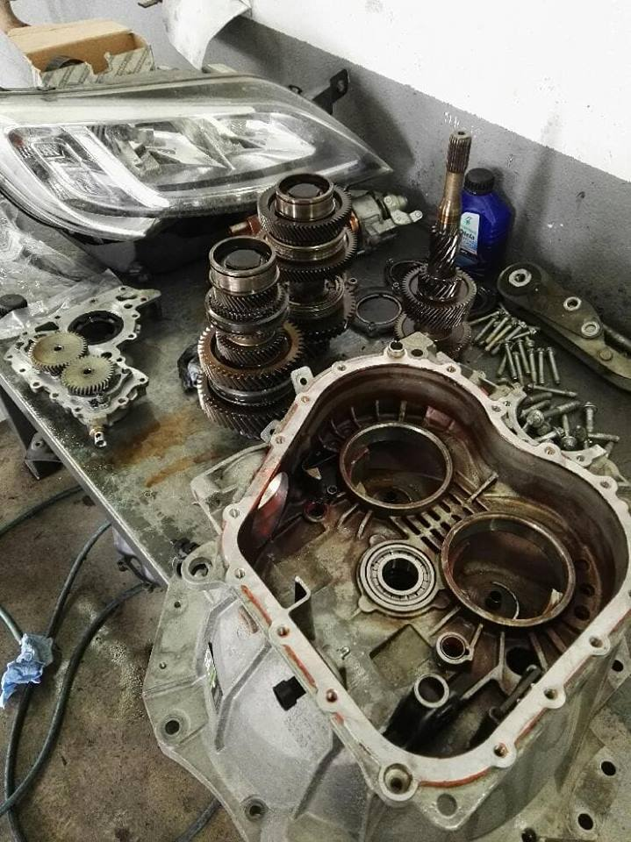
PROJECT MANAGEMENT
1. Mobility Project Preparation & Induction
Before the arrival of your trainees in Spain, euroMind provided them with the pre-arrival guide, including useful information, local transport & social life, emergency numbers.
euroMind has also arranged Skype meeting with the participants in order to get to know them and to interview them.
After the Skype interview, euroMind created a Facebook group to which all the selected participants were invited, together with their Teachers. This way euroMind Coordinator had constant contact with the target group already before their arrival in Spain.
Once the Skype interviews were delivered, euroMind upon a thorough analysis of the participants’ studies and profile provided each one of them with an adequate work placement.
euroMind took responsibility for preparing Learning Agreements individually for each participant and made sure that all the parties involved signed all the necessary documents.
On the first day after the arrival, euroMind organized the welcome session during which the participants got to know the euroMind team, were reminded about the programme agenda, accommodation rules and dissemination strategy options.
Later on, the participants were taken for a walk around the neighborhood to get to know the area and find out where banks, mail box, workplace, supermarkets, bus station are.
2. Monitoring & Monitoring
In order to make sure that the objectives of the Learning Agreement were going to be achieved and that the participants would be fully integrated in the companies’ work culture, the monitoring was delivered by all of the parties involved in the project.
euroMind assigned a Mentor for the group of participant who was responsible for the introduction of the participants to the host organisation(s). During the work placement/training the Mentor delivered monitoring visits to the work placements in order to revise the tasks of the trainees, their progress as well learn from the first hand the level of satisfaction of both the participants and the host companies/ training centre tutor.
The mentor in cooperation with companies Tutors carried out the evaluations of the trainees in the middle and at the end of the trainings.
After obtaining the results of the half-way through evaluation, the Mentor met the participants to give them the results of this evaluation. The least favourable results were discussed with the participants in private so that both the Mentor and the trainees had the comfort of sharing the information and exchanging the opinions and finding solutions to some problematic issues.
Host organisations assigned a member of its staff as a tutor. The tutors from the host companies were responsible for helping, informing and guiding and supervising the work done by the participants. The tutors had regular meetings with the participants in order to assess their presence in the company as well as to discuss the tasks and responsibilities according to the needs of the company and the participants.
euroMind at the end of the programme during the goodbye session handed out evaluation sheets to the participants so that they could assess their stay in Spain, work placements, as well as the work of the euroMind.
euroMind was also available to the participants 24/7 in case of emergency.
3. Communication
EuroMind takes good care of successful communication between companies and trainees. Each evaluation of work is aimed at improving the quality of cooperation. Each party is thoroughly checked and assessed and the necessary improvements are introduced. Moreover, euroMind mediates in this supervisor-trainee collaboration by translating and solving language-connected complicated matters.
4. Dissemination strategy
euroMind took active part in the process of preparing and dissemination results of the project together with the sending organisation and participants.
While the trainees were in Spain, euroMind involved them in a number of activities the aim of which was to make students monitor and collect all the information related to the progress of their work placements and stay in Spain. The materials produced by the participant would be then used as tools for disseminating results by the school in their country and by the partner in Spain.
The participants could work in groups or individually. On the first day they needed to decide on the form or forms of recording their professional experiences.
As a rule the whole group needed to create a Facebook fun page as it is an effective and quick means of accessing large numbers of people. What is more, it is a form that appeals to young people as they can share their experiences instantly and receive instant feedback, too. The fan page is always linked to the euroMind’s Facebook fan page. The sending organisation was also asked to do the same thing.
This way the material produced by the trainees reached bigger audiences and was more effectively disseminated.
Apart from the Facebook fan page, the trainees were encouraged to prepare a PowerPoint presentation in English and the video which they would be able to use to disseminate the results of the project back home (conferences, meetings with other students, parents, etc.).
euroMind also disseminates the project at a local level. It organises language and cultural exchanges between the international trainees and students from local vocational colleges. During those meetings both Spanish and International students are involved in a number of activities the aim of which is to get to know each other, share experiences related to work experiences and in general their stay in Spain. The students also exchange information about their countries and cultures.
5. Certification
To validate the acquired skills, the trainees, at the end of their stay, received complete proof of their participation in the project by means of several methods of recognition:
  - Training Certificate
  - Europass Mobility Certificate
  - ECVET if applicable
  - Spanish Course Certificate if applicable
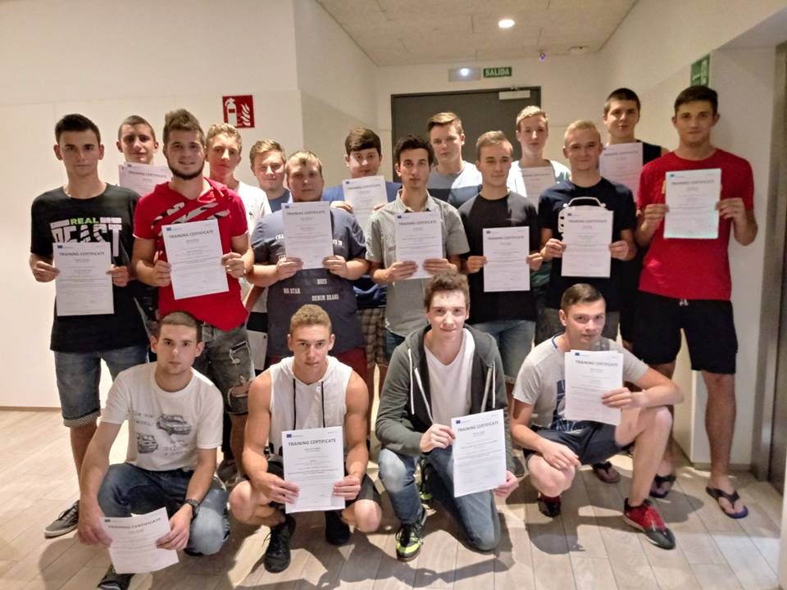
CULTURAL & LINGUISTIC PREPARATION
1. Spanish course: teaching method & participants´ outcomes
The group was given very intensive Spanish lessons with our Spanish Teacher. euroMind’s teaching methods were very effective as they made learning fun through playing games and creating an enjoyable atmosphere in the class. The Spanish classes can be described by 2 words: dynamic and practical! We used an interactive method of teaching based on learning by practicing. This means that grammar was covered as much as possible by using practical situations. Therefore, speaking and actively using the language is crucial and central in all our activities delivered. After intensive and hard learning the students had a written an exam. All of the participants passed with very good results!
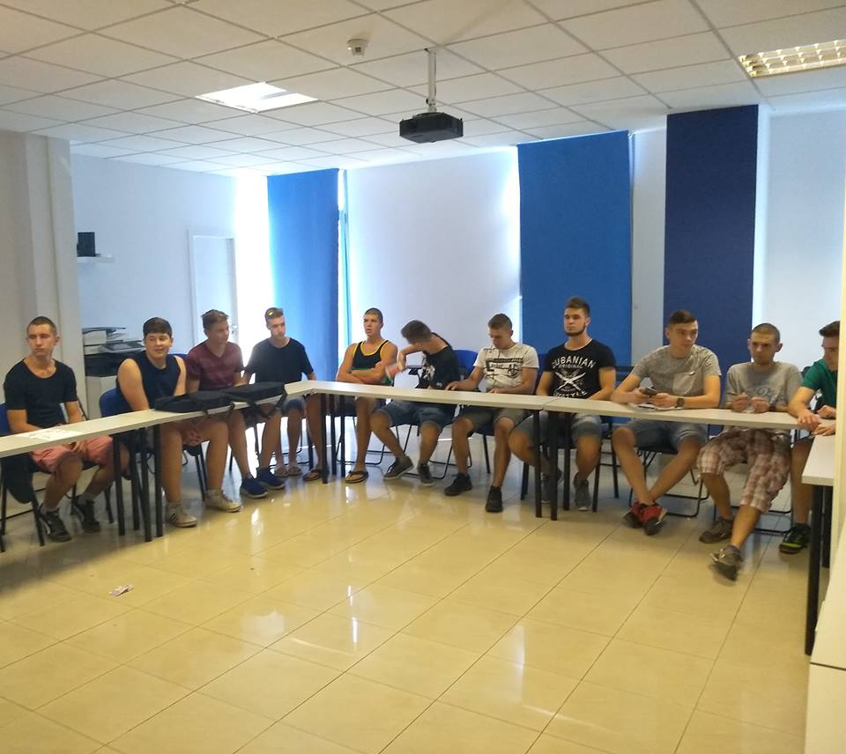
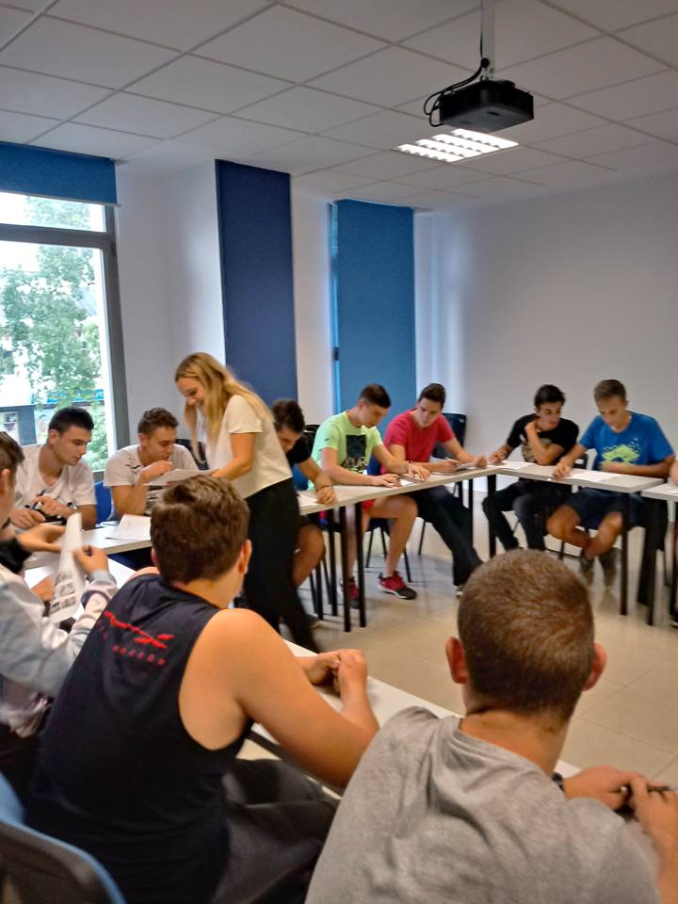

2. Study Visit
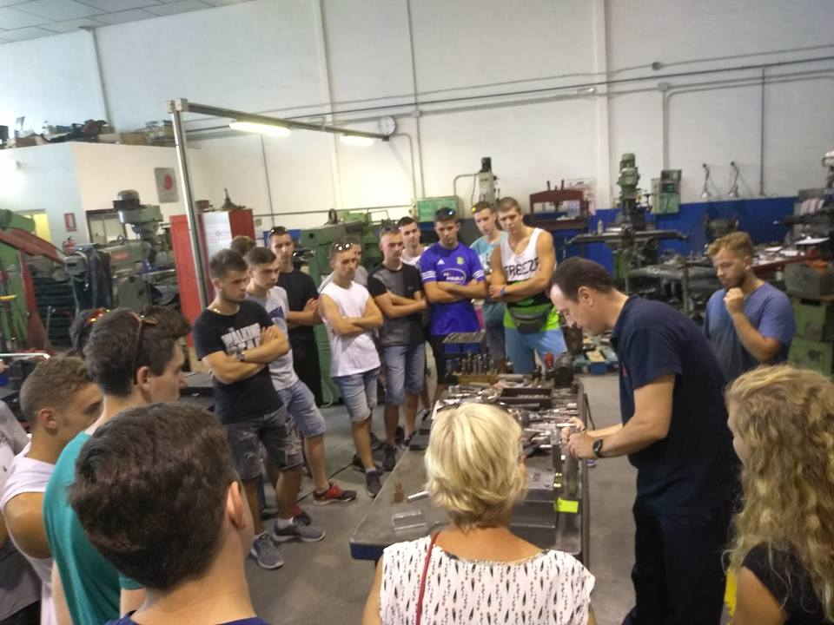
Study Visit - Moldes & Matrices Mesán : Moldes Mesán is a company dedicated to the manufacture and repair of specific tools. They are mainly involved in the creation of moulds and dyes. They possess advanced machinery for different types of projects: CNC machining centres, EDM wire and penetration machines, CNC milling machines, as well as a full fleet of machinery of different applications: milling machines, bending machines, shears, presses, etc.
The visit is intended to make students understand the functioning and structure of a company highly developed in technology dedicated to the manufacture of moulds and dyes. They will also gain more insight into the functioning of CNC machinery.

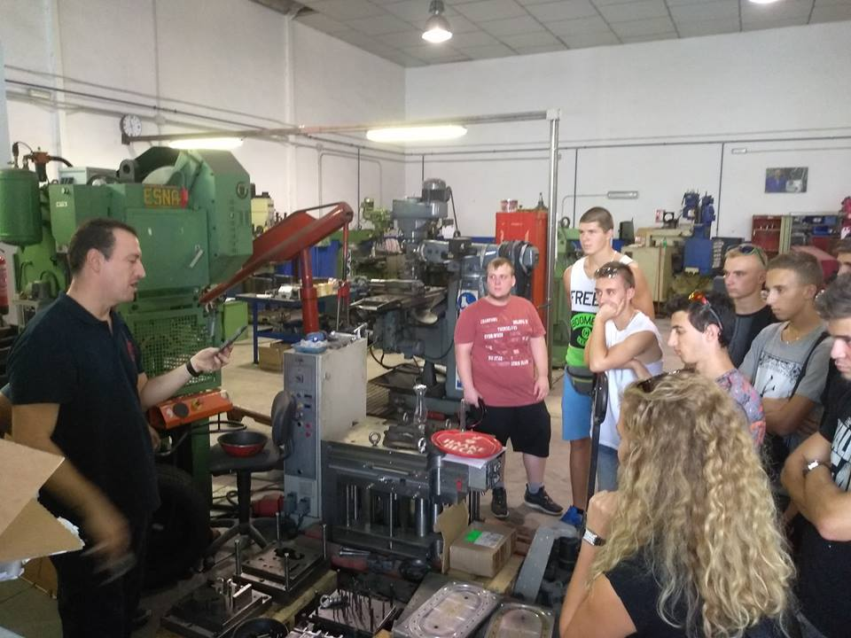

3. Cultural activities, Andalusian cities & places visited during the programme
Stadium Tour ( min. 15 pax) : The group have a chance to visit the Real Betis Balompié Stadium located in the Heliópolis neighbourhood in the Paseo de la Palmera. The Betis Stadium was founded on 12th September 1907 when the honorary royal distinction (Real) was received from Alfonso XIII in 1914. The club’s name is characterized by the fact that it is one of the few teams in the country with a completely Spanish denomination, and the oldest of them all. Following redevelopment works in 2000 this Green-and-White coliseum increased its capacity to 52,000, further seating was installed and the facilities were improved. After visiting grandstands, changing rooms and the conference hall together with the guide, the group have some free time to do a shopping in a local Betis store.
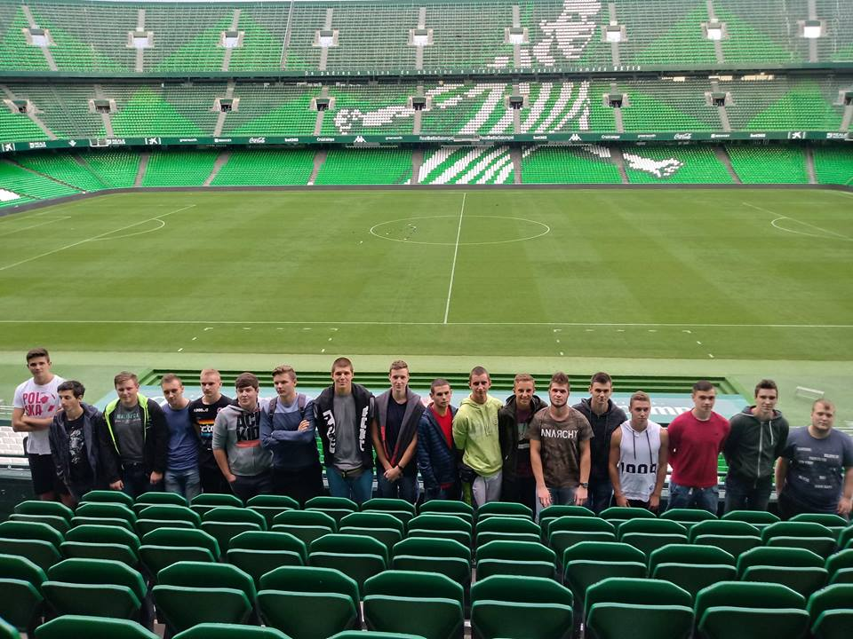

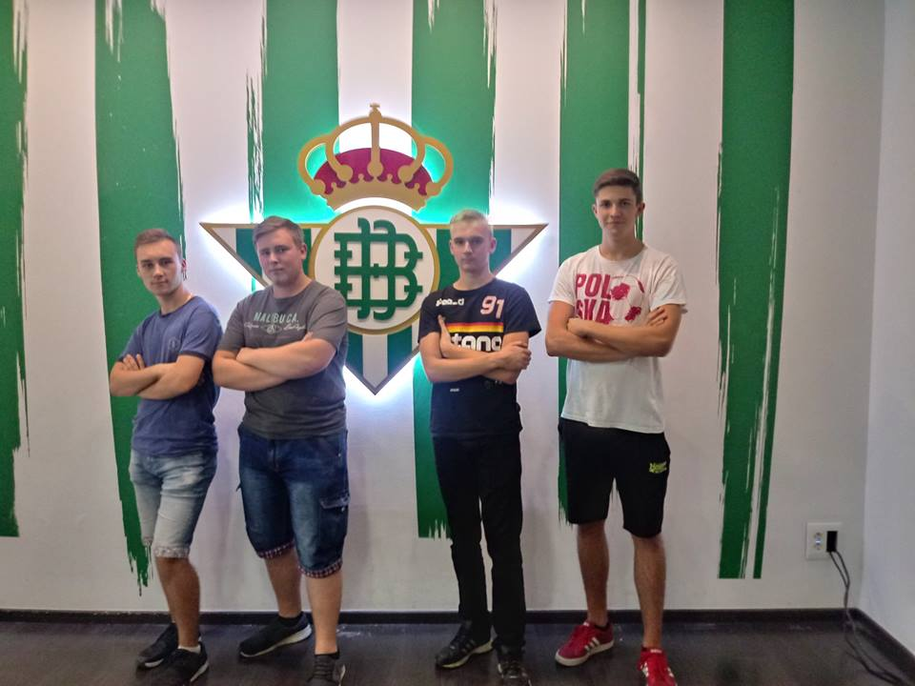

The Royal Bullring, La Real Maestranza : The Royal Bullring is possibly one of the most important artistic monuments in Seville. Every year as the bullfighting season comes around the Royal Bullring is filled to its capacity with fans applauding the bravery of the matadores. During the visiting tour, the participants are able to experience the emotions that might be felt by a bullfighter or a member of the public. They also visit the Bullfighting Museum, which contains an exhibition of paintings and a selection of the bullfighting prints which belong to the Real Maestranzas collection, one of the largest in the world. Seville Tour : Seville is the artistic, cultural, and financial capital of Andalusia region in the southern Spain. The city is a historical masterpiece full of monuments, gardens and flamenco festivals. The city reflects the harmony between different Christian, Jewish and Muslim cultures and religions. As Seville is the capital and the largest city of the autonomous community of Andalusia, it is easy to get lost here, however thanks to the tour organised by euroMind´s team, the trainees can admire the city safely and in a pleasant atmosphere. The euroMind coordinator helps our trainees understand the city from a historical and artistic point of view, but also gives them some shopping and eating tips. The group is showed the most attractive places where they can go and grab something to eat, drink, have fun or just relax and hang out.
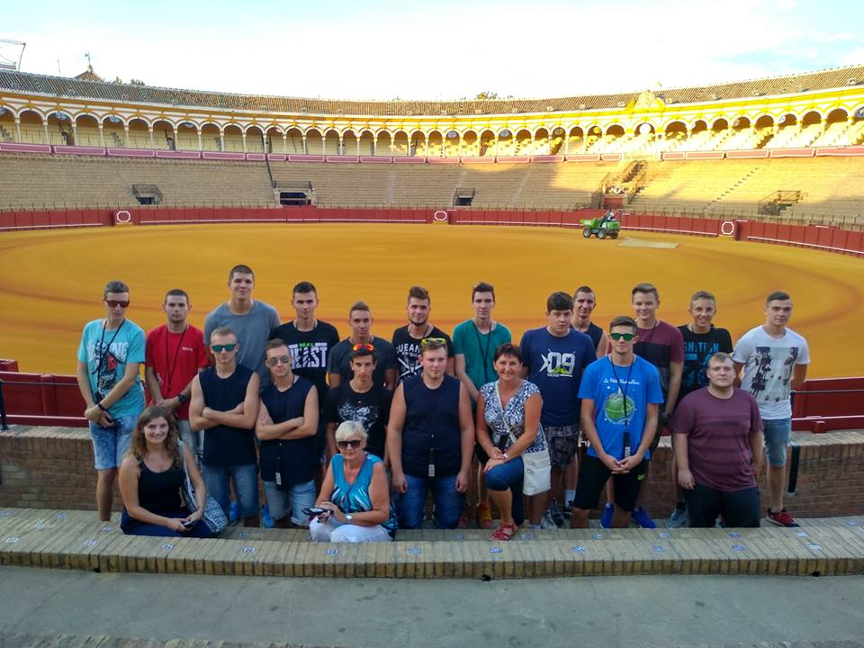

Tavira (Portugal) : Tavira is a charming, traditional and historic town on the eastern side of Algarve, Portugal. The village is situated on the banks of the Gilao River and is close to the stunning beaches of the Ilha de Tavira. The town, proclaimed as a slow city is rightly regarded as the most picturesque one in the region of the Algarve. The group visited the centre of Tavira that is filled with numerous churches, historic monuments and traditional buildings, such as the ancient Ponte Romana Bridge and the Praça da Republica square. Further up the hill, we got to the castle, the ancient Santa Maria church and the colourful Convento da Graça. Last point of the trip was reaching the Ilha de Tavira to enjoy the beautiful beach located on the island that extends for over 12km and is connected to the town by a regular ferry.
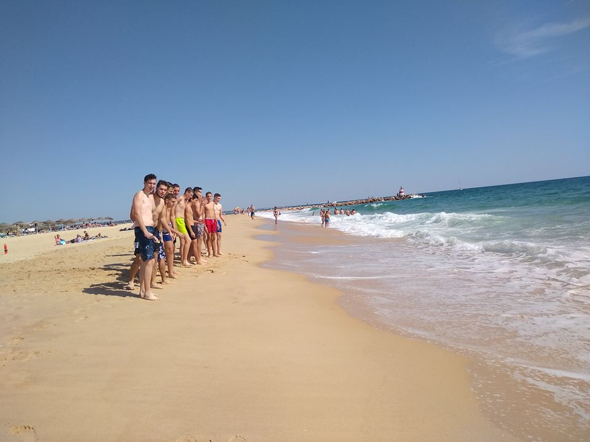

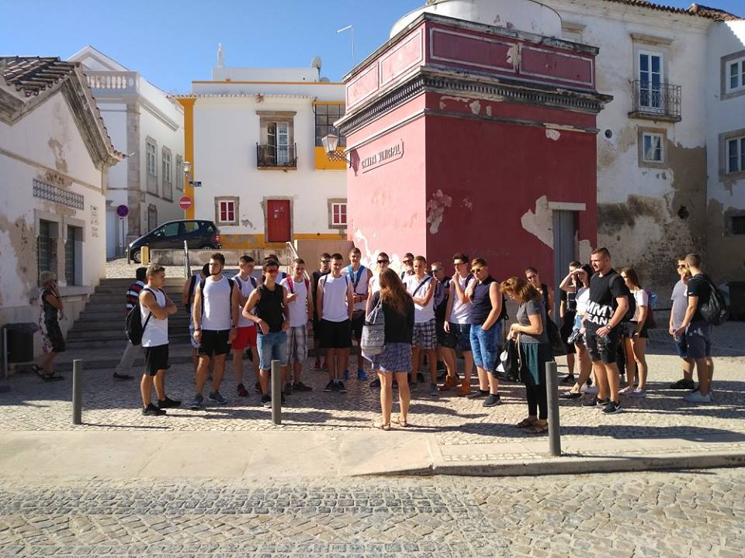

Malaga : Malaga is not only the centre of the night life, shopping, cafés and beach chilling, but is also a perfect place for enthusiasts of a history, art and architecture. The city is one of the oldest one in the world and is wealth of magnificent monuments that will intrigue many enthusiasts of art and history. Participants began to explore the city from the Gibralfaro and Alcazaba Palace. They also saw an old Roman Theatre, the Cathedral, which was built through the XVI- XVIII centuries. Since Malaga is located on the Costa del Sol (Coast of the Sun) which is considered to be one of the most beautiful coasts in Spain, the group also had a chance to take a rest and relax at long and sandy Malagueta Beach by the Mediterranean Sea, where we finished our trip. No :
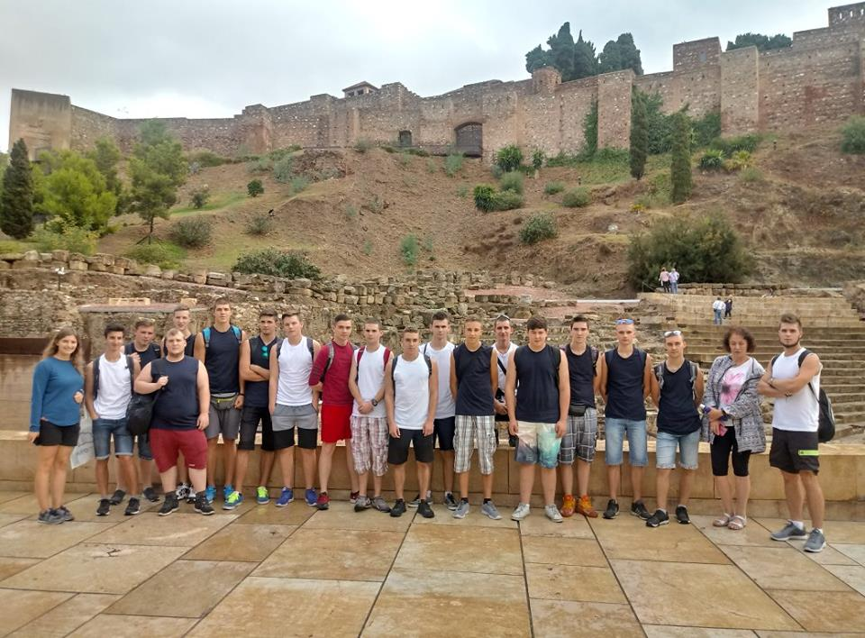
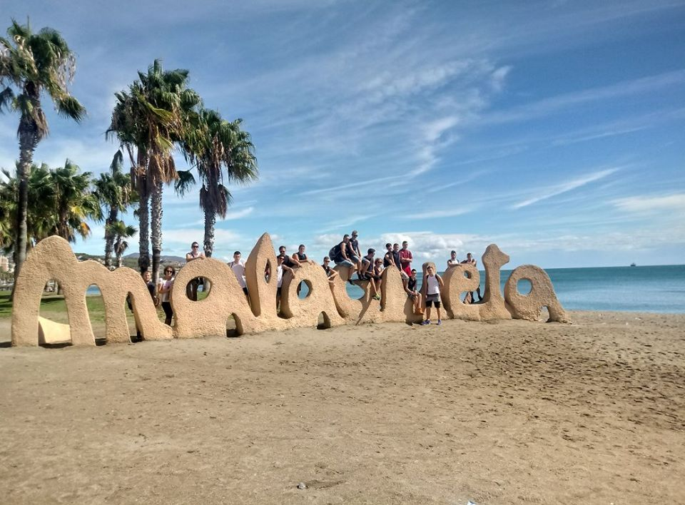
SUMMARY OF THE PROJECT
euroMind team did their best in order to deliver the best professional and cultural experience to the trainees of the project being always ready to help, give advice and solve any problems or doubts.
The trainees were fully satisfied with their work placements. They gained much needed professional experience abroad which is highly appreciated and sometimes even specifically asked by today’s employers.
We have no doubt that our trainees will use their new knowledge and experience at their current work in their home country or increase their chances at the labour market and dazzle their future potential employers.
Moreover, the trainees learnt the basics of the Spanish language were able to work in a multi-cultural environment and proved themselves with the ability to work individually as well as in a team.
euroMind team was extremely satisfied with the trainees’ involvement in the project and personal interest in whatever they participated in.
This project was very successful and we hope to realize other successful projects with Zespol Szkol Technicznych i Ogolnoksztalcacych w Skoczowie in the future.

SEVILLA, 26-10-2018

Carlos Hoyo de la Torre
Director

